創業、當老闆早已不是什麼新鮮事。許多人都會嘗試創辦自己的公司或實現自己的商業理念。從像在線銷售產品這樣的小生意，到接管家族企業或白手起家，關於如何建立和發展商業機會的資源一直很受歡迎。

Wiley精選管理類書籍涵蓋各類行業、教材和專業書籍。最適合圖書館，或用於創業、工商管理和小型企業管理個人等使用。

小型企業和創業 (Small Business & Entrepreneurship Titles)
Starting your own business and being your own boss is nothing new. Many people will give building their own company or business idea a try. From something small like a side hustle of selling products online, to taking over a family a business or starting a business from scratch; resources on building and growing business opportunities continue to be popular.

The featured include a mix of trade, textbook and professional titles. They are best suited for retailers, distributors supplying to libraries who carry range or for courses such as Entrepreneurship, Business Administration and Small Business Management.

  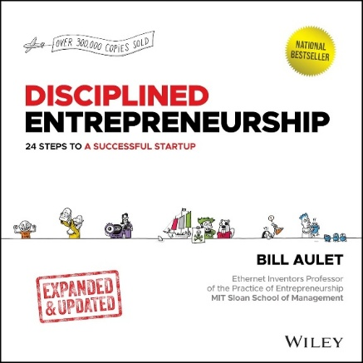
  9781394222513
  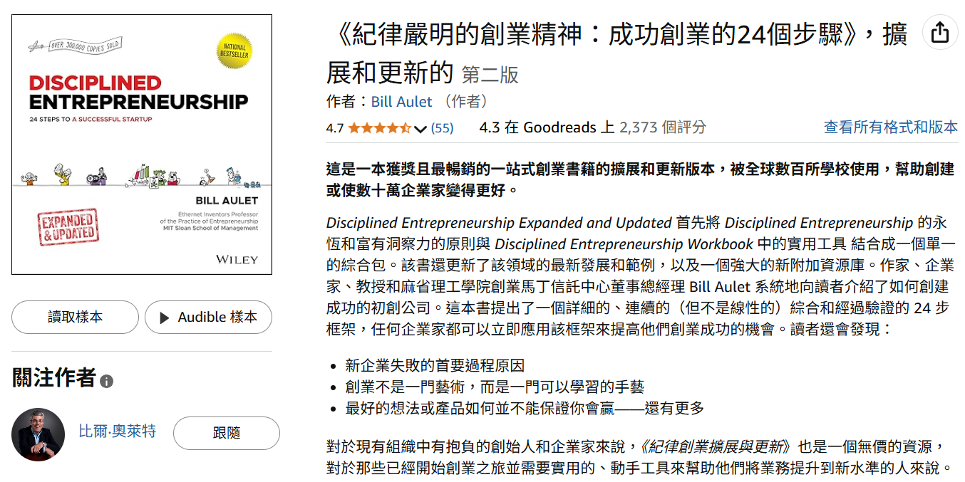
  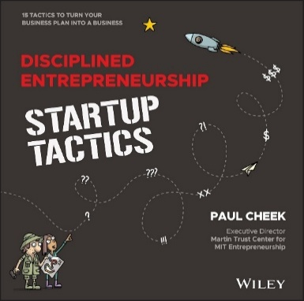
  9781394223350
  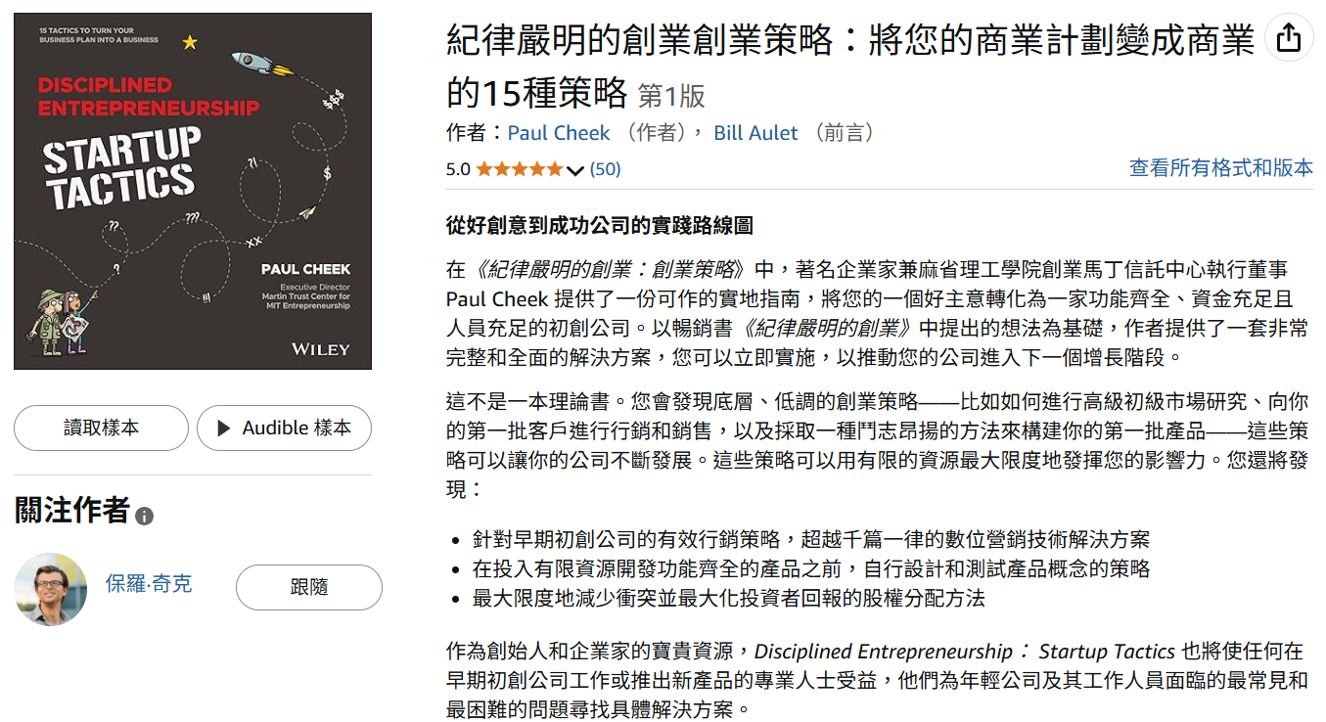

  
  9781394194544
  
  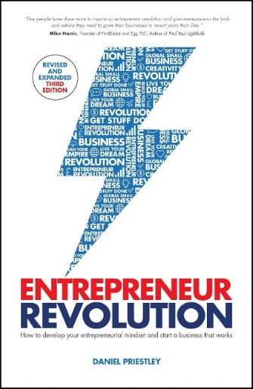
  9780857089731
  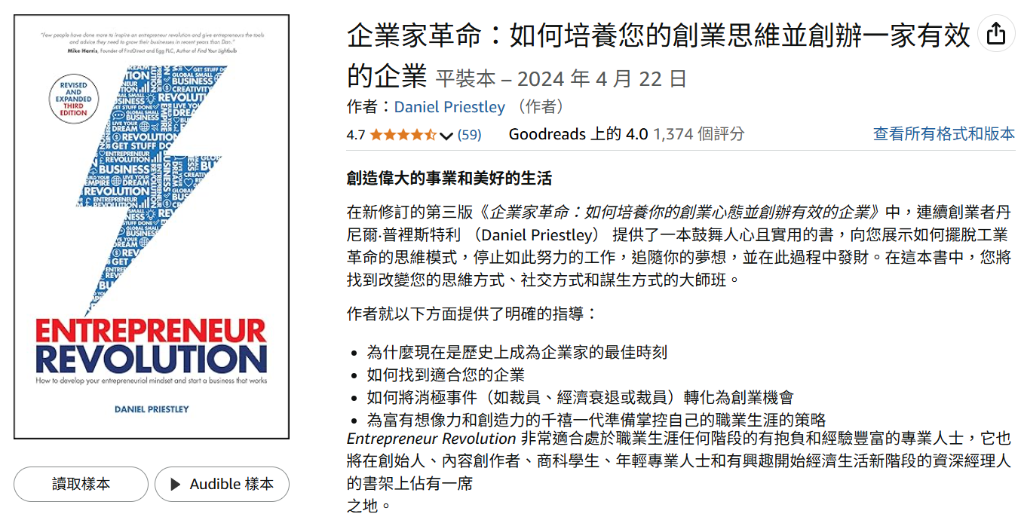
  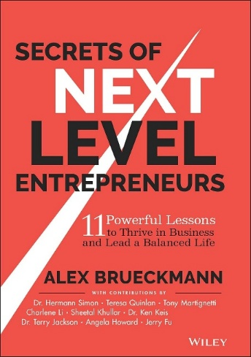
  9781394185382
  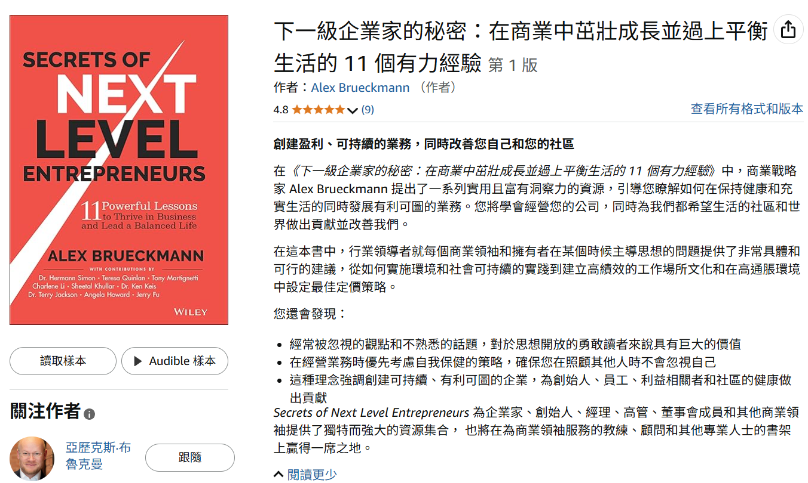

  
  9781394324675
  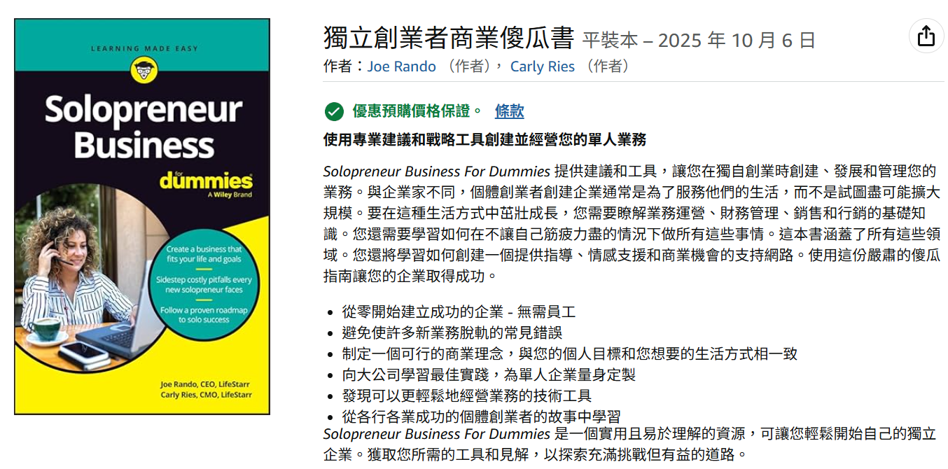
  
  9781394194575
  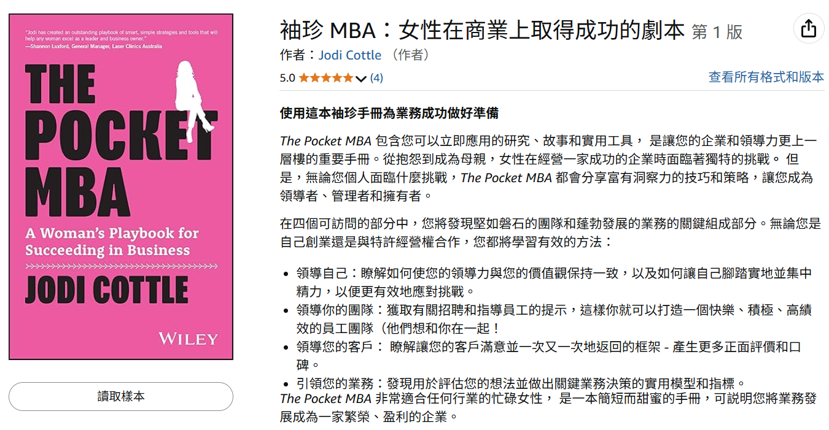
  
  9780730394525
  

  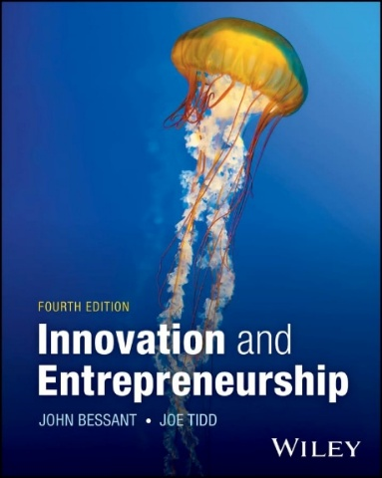
  9781394219704
  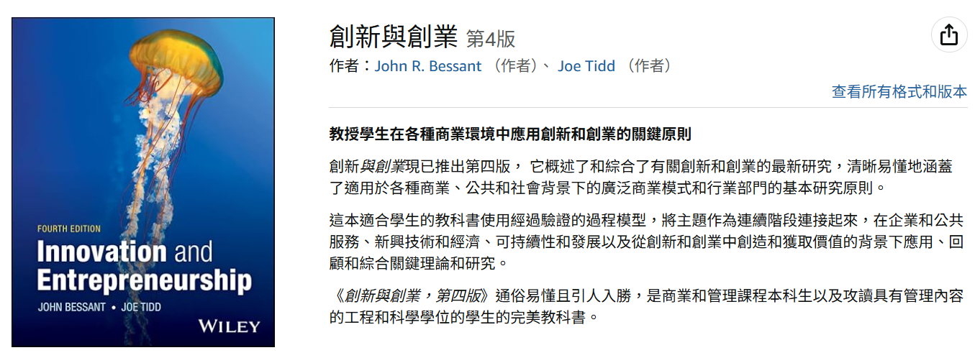
  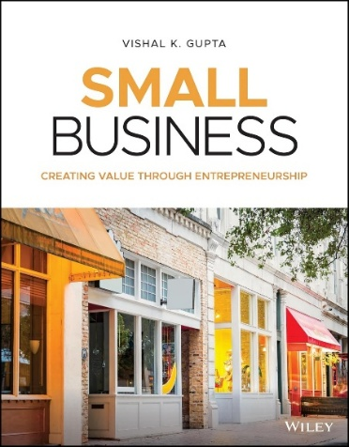
  9781119591771
  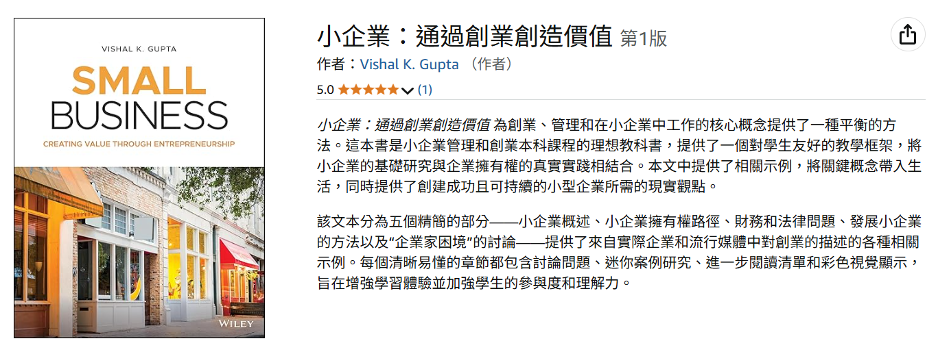
  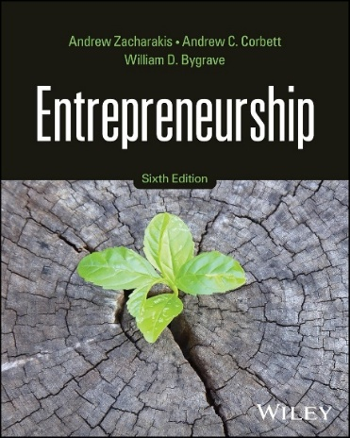
  9781394262809
  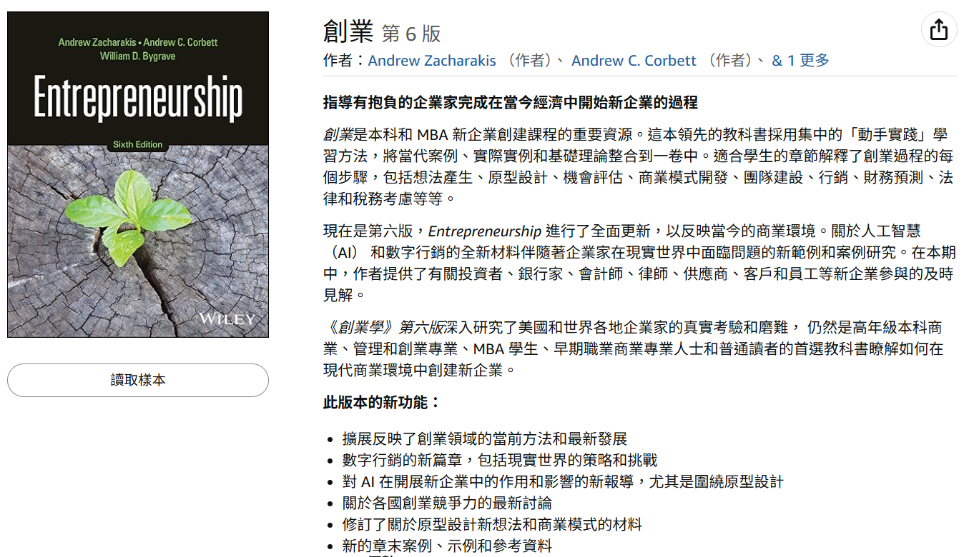

  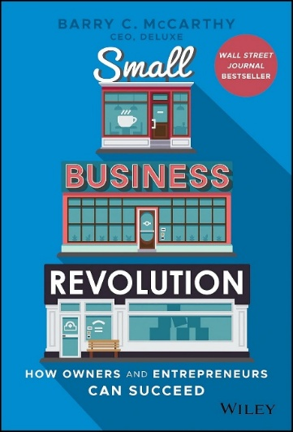
  9781119802648
  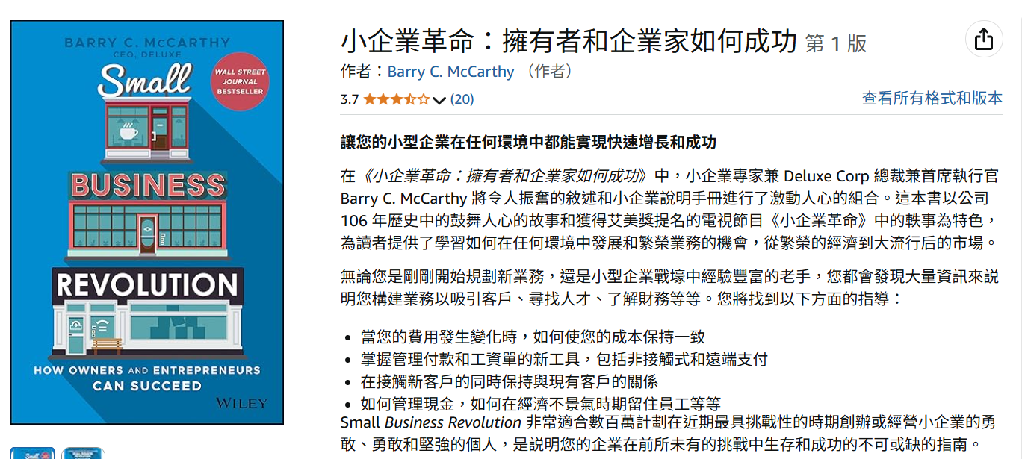
  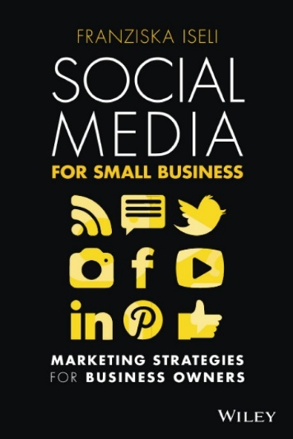
  9780730390329
  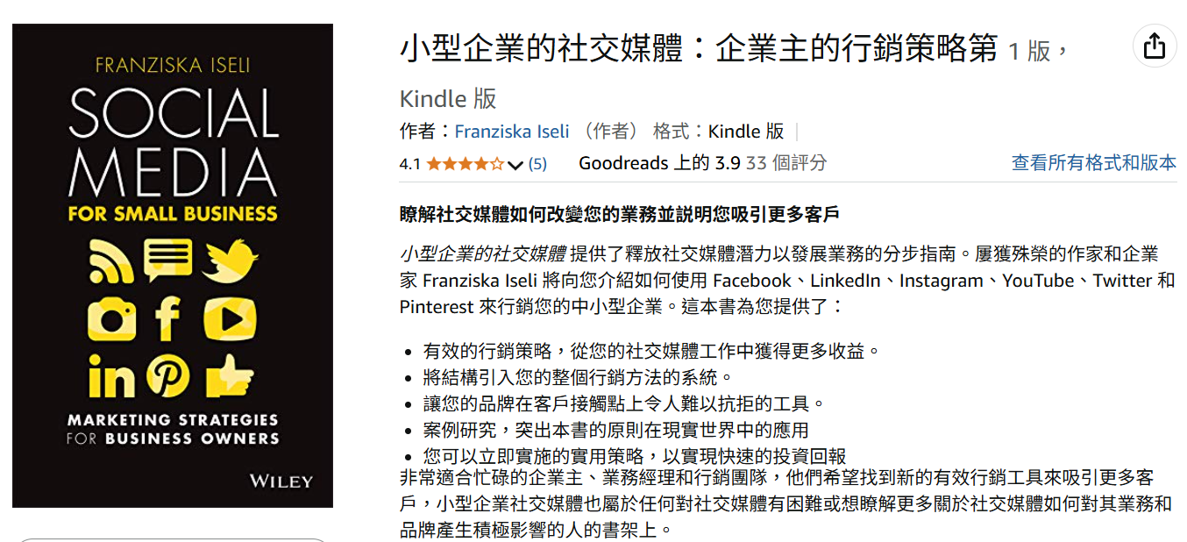
  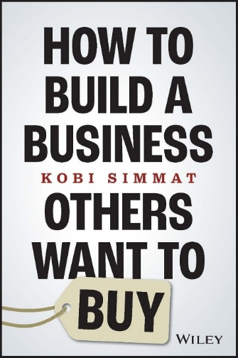
  9781394194605
  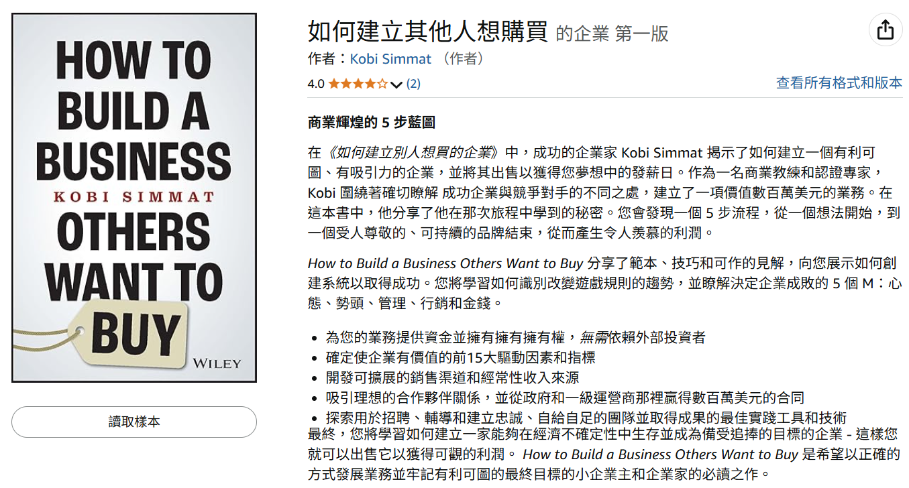

Wiley Asia : Business Management – Small Business & Entrepreneurship 2025 June/2 Update
ISBN | Title | Category | Bind | Pub Date | Prices (US$) | Prices SG$ b/f GST
9781394262809 | ENTREPRENEURSHIP, 6TH EDITION | College Textbook | Paper | 2025/2/19 | 90.95 | 115.95
9781394237340 | GETTING STARTED IN BUSINESS PLANS FOR DUMMIES | Trade | Paper | 2025/2/17 | 19.95 | 27.95
9780730394525 | SELLING ONLINE FOR DUMMIES | Trade | Paper | 2025/2/7 | 25.99 | 35.95
9781394321650 | BUFFALO, BARRELS, & BOURBON: THE STORY OF HOW BUFFALO TRACE DISTILLERY BECAME THE WORLD'S MOST AWARDED DISTILLERY | Trade | Paper | 2025/1/2 | 17.95 | 24.95
9781394321643 | BULLEIT PROOF - HOW I TOOK A 150-YEAR-OLD FAMILY RECIPE, AND A REVOLVER, AND DISRUPTED THE ENTIRE LIQUOR INDUSTRY ONE BOTTLE, ONE SIP | Trade | Paper | 2025/1/2 | 17.95 | 24.95
9781394298013 | YOUR AI ROADMAP: ACTIONS TO EXPAND YOUR CAREER, MONEY, AND JOY | Trade | Paper | 2024/12/10 | 34.95 | 48.95
9781394309535 | THE 9% EDGE PLANNER: A QUARTERLY GUIDE TO HELP YOU MAINTAIN CLARITY, STAY FOCUSED, AND KEEP YOU ON TRACK FOR SUCCESS | Trade | Paper | 2024/11/14 | 21.95 | 30.95
9781394195756 | THE UNNOTICED ENTREPRENEUR, BOOK 3 - HOW ENTREPRENEURS CAN LEVERAGE THEIR AUTHENTICITY TO BUILD BRANDS | Trade | Paper | 2024/10/17 | 18.99 | 26.95
9781394279029 | STILL STANDING: WHAT IT TAKES TO THRIVE AND INNOVATE IN A MESSY WORLD | Trade | Cloth | 2024/10/9 | 29.95 | 41.95
9781394253685 | THE CUSTOMER EXCELLENCE ENTERPRISE: A PLAYBOOK FOR CREATING CUSTOMERS FOR LIFE | Trade | Cloth | 2024/9/16 | 27.95 | 38.95
9781394243266 | THE ULTIMATE GUIDE TO RESPONSIBLE FRANCHISING: IDENTIFYING AND INVESTIGATING THE RIGHT FRANCHISE TO MAXIMIZE YOUR REWARDS AND MINIMIZE RISK | Trade | Cloth | 2024/9/16 | 29.95 | 41.95
9781394264438 | THE MAC & CHEESE MILLIONAIRE: BUILDING A BETTER BUSINESS BY THINKING OUTSIDE THE BOX | Trade | Cloth | 2024/8/21 | 27.95 | 38.95
9781394195343 | THE UNNOTICED ENTREPRENEUR - GIVING ENTREPRENEURS THE TOOLS THEY NEED TO GET THE RECOGNITION THEY DESERVE | Trade | Paper | 2024/4/1 | 18.99 | 26.95
9780857089731 | ENTREPRENEUR REVOLUTION - HOW TO DEVELOP YOUR ENTREPRENEURIAL MINDSET AND START A BUSINESS THAT WORKS | Trade | Paper | 2024/3/26 | 18.99 | 26.95
9781394242764 | SMALL BUSINESS FOR DUMMIES, 6TH EDITION | Trade | Paper | 2024/3/12 | 29.95 | 41.95
9781394219704 | INNOVATION AND ENTREPRENEURSHIP, 4TH EDITION | College Textbook | Paper | 2024/3/8 | 105.95 | 147.95
9781394222513 | DISCIPLINED ENTREPRENEURSHIP EXPANDED AND UPDATED: 24 STEPS TO A SUCCESSFUL STARTUP | Trade | Cloth | 2024/3/8 | 38.95 | 54.95
9781394223350 | DISCIPLINED ENTREPRENEURSHIP STARTUP TACTICS - 15 TACTICS TO TURN YOUR BUSINESS PLAN INTO A BUSINESS | Trade | Cloth | 2024/3/8 | 36.95 | 51.95
9781394241712 | FUNDING A NEW BUSINESS FOR DUMMIES | Trade | Paper | 2024/3/4 | 29.95 | 41.95
9781394217380 | CONQUER THE CHAOS: THE SIX KEYS TO SUCCESS FOR ENTREPRENEURS | Trade | Cloth | 2024/2/6 | 29.95 | 41.95
9781394205844 | GET GROWING: GET CLIENTS, GROW FASTER, AND SPEND LESS TIME SELLING | Trade | Cloth | 2024/1/29 | 27.95 | 38.95
9781394194544 | SELF-MADE: BUILD A BIG LIFE FROM A SMALL BUSINESS | Trade | Paper | 2023/8/28 | 19 | 26.95
9781394201655 | STARTING & RUNNING A BUSINESS ALL-IN-ONE FOR DUMMIES, 4TH EDITION (UK EDITION) | Trade | Paper | 2023/8/11 | 30.95 | 42.95
9781394194605 | HOW TO BUILD A BUSINESS OTHERS WANT TO BUY | Trade | Paper | 2023/6/13 | 19 | 26.95
9781119887805 | ALL MONEY IS NOT CREATED EQUAL: HOW ENTREPRENEURS CAN CRACK THE CODE TO GETTING THE RIGHT FUNDING FOR THEIR STARTUP | Trade | Cloth | 2023/6/8 | 27.95 | 38.95
9781394194575 | THE POCKET MBA: A WOMAN'S PLAYBOOK FOR SUCCEEDING IN BUSINESS | Trade | Paper | 2023/5/12 | 16 | 21.95
9781394184552 | THE VERY GOOD MARKETING GUIDE: HOW TO GROW YOUR BUSINESS ON A BUDGET | Trade | Paper | 2023/5/2 | 21 | 28.95
9781119900542 | ORIGINATE, MOTIVATE, INNOVATE: 7 STEPS FOR BUILDING A BILLION DOLLAR NETWORK | Trade | Cloth | 2023/4/11 | 25.95 | 35.95
9781119903727 | THE SPACE ECONOMY: CAPITALIZE ON THE GREATEST BUSINESS OPPORTUNITY OF OUR LIFETIME | Trade | Cloth | 2023/3/23 | 29.95 | 41.95
9781394185382 | SECRETS OF NEXT LEVEL ENTREPRENEURS: 11 POWERFUL LESSONS TO THRIVE IN BUSINESS AND LEAD A BALANCED LIFE | Trade | Cloth | 2023/3/10 | 27.95 | 38.95
9780857089571 | THE UNNOTICED ENTREPRENEUR - STEP INTO THE SPOTLIGHT | Trade | Paper | 2023/1/20 | 18.99 | 26.95
9781786308061 | CLIMATE INVESTING - NEW STRATEGIES AND IMPLEMENTATION CHALLENGES | Professional Reference | Cloth | 2023/1/20 | 164.95 | 230.95

