


EAN：9781398619050
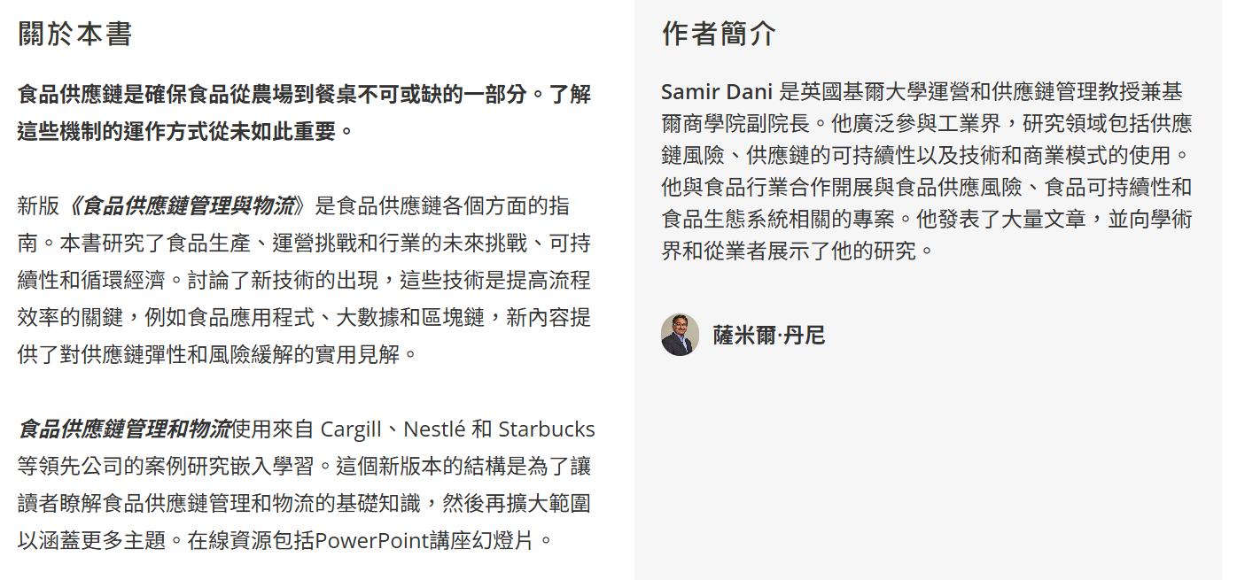

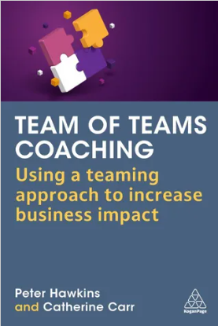
EAN：9781398613959
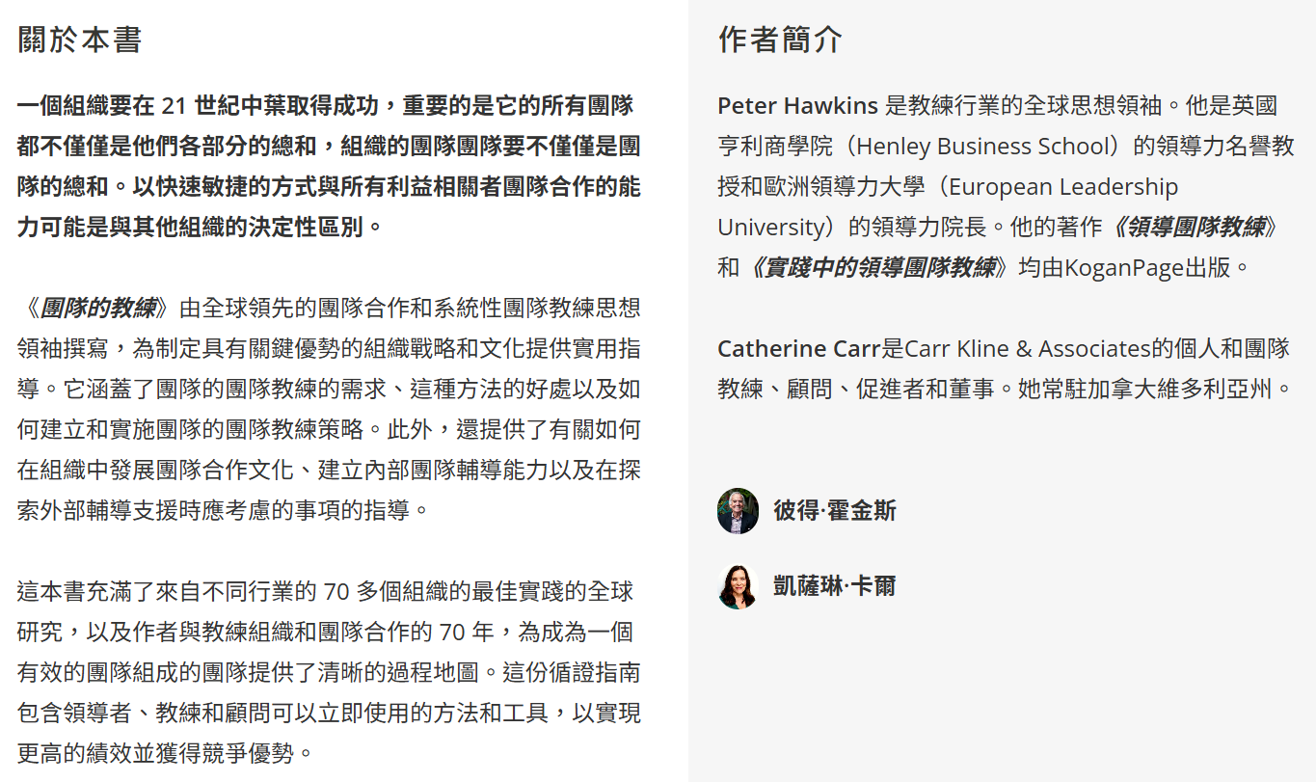


EAN：9781398618992
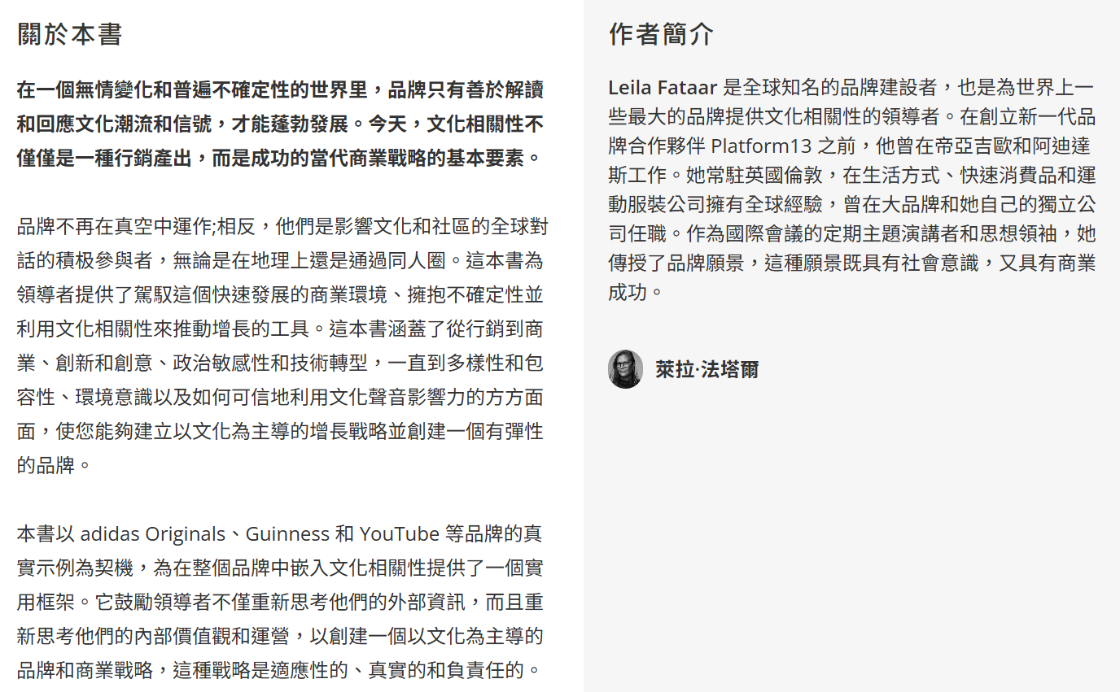


EAN：9781398621008
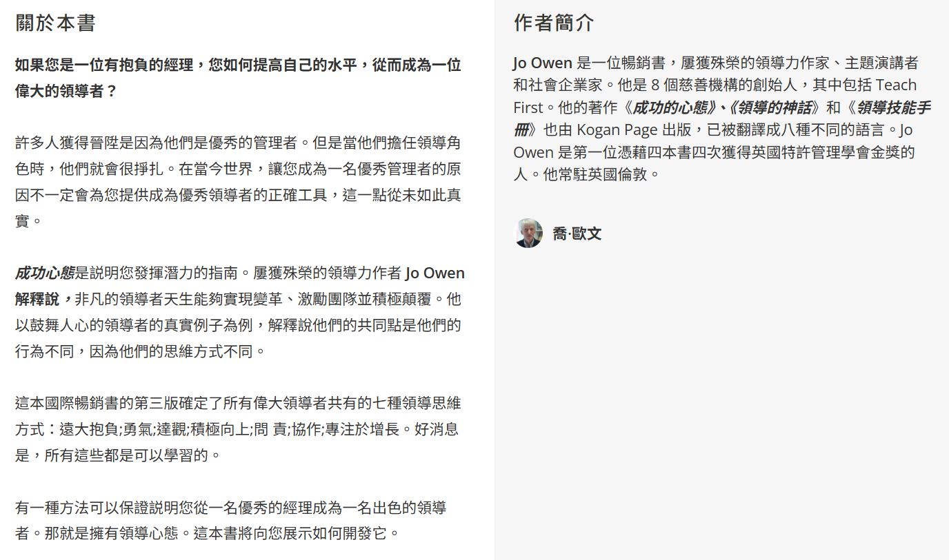

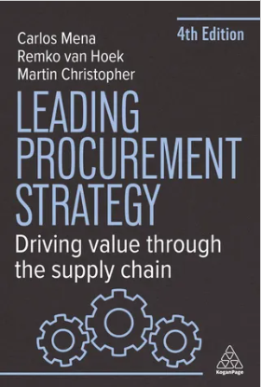
EAN：9781398619517
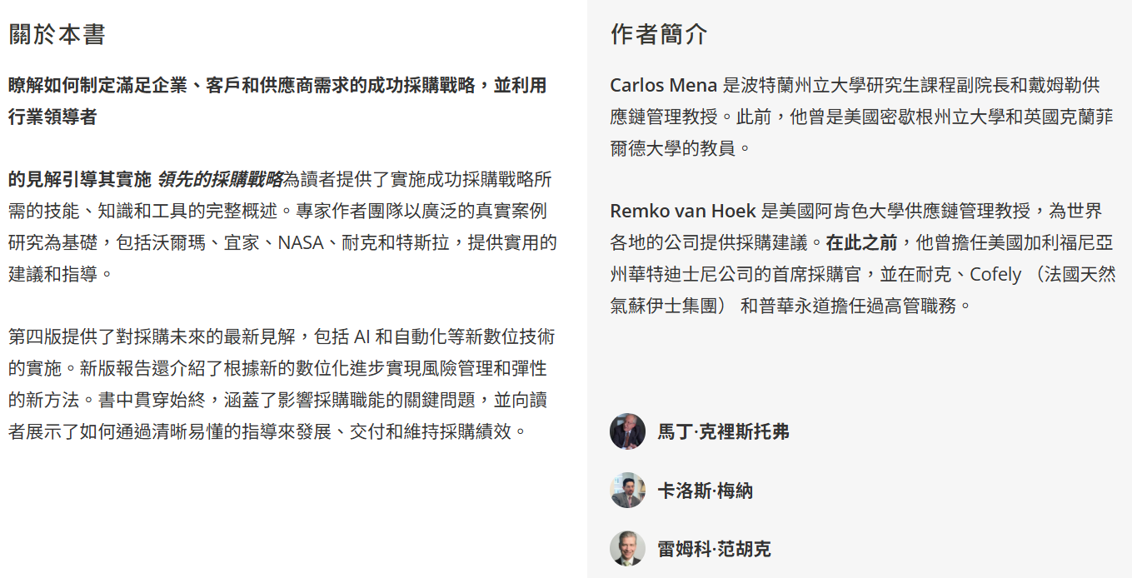


EAN：9781398620018
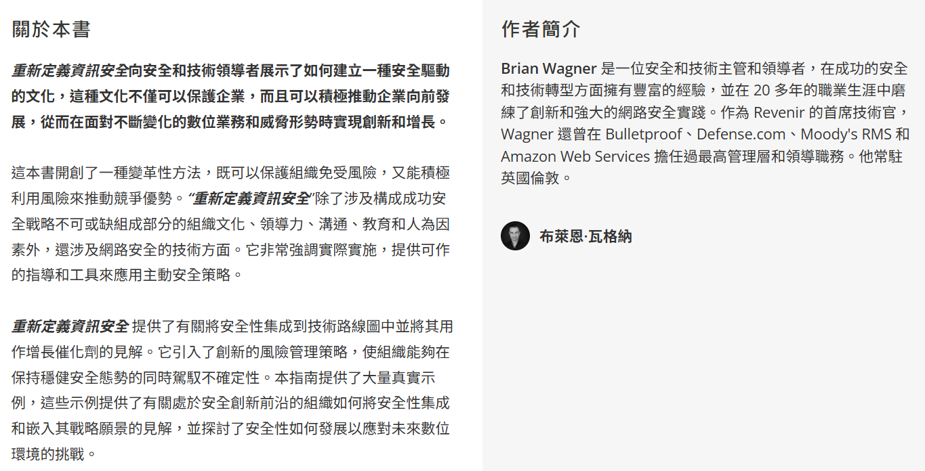


EAN：9781398618749
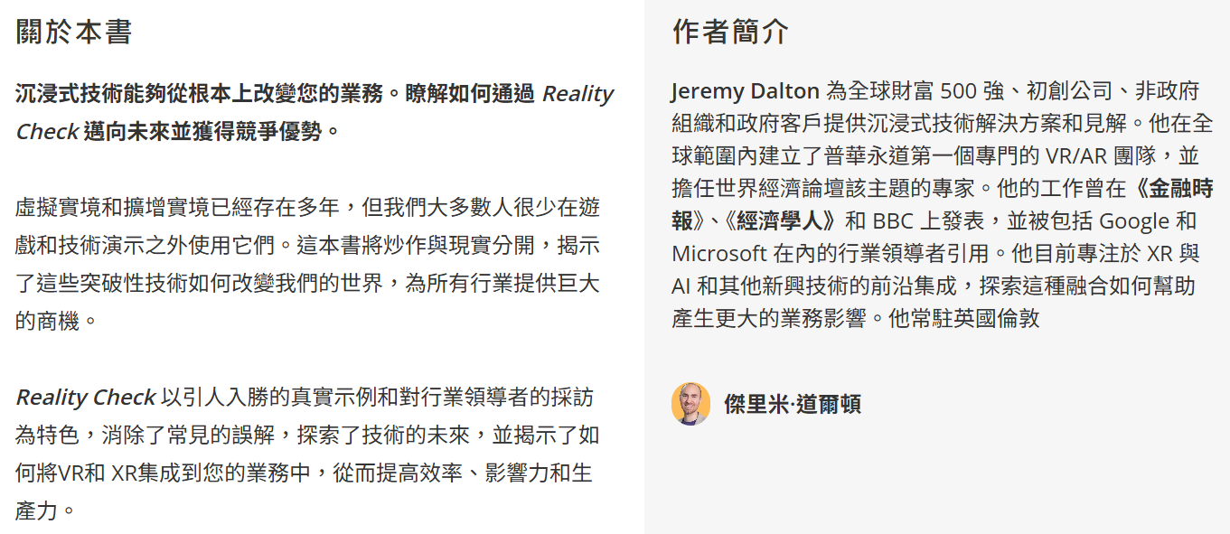

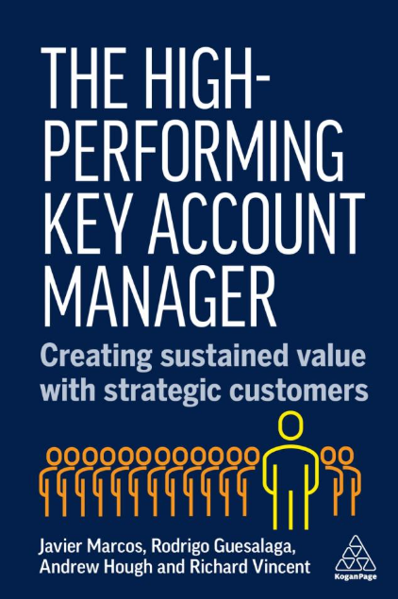
EAN：9781398620308
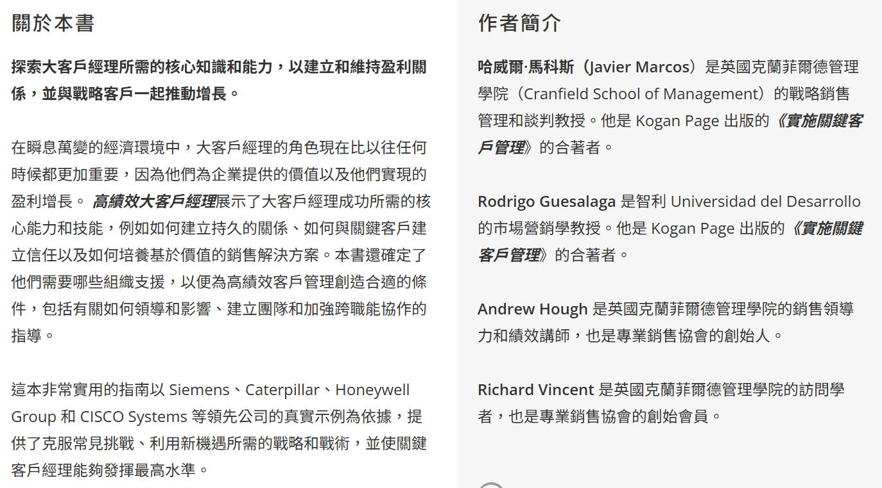


EAN：9781398619715
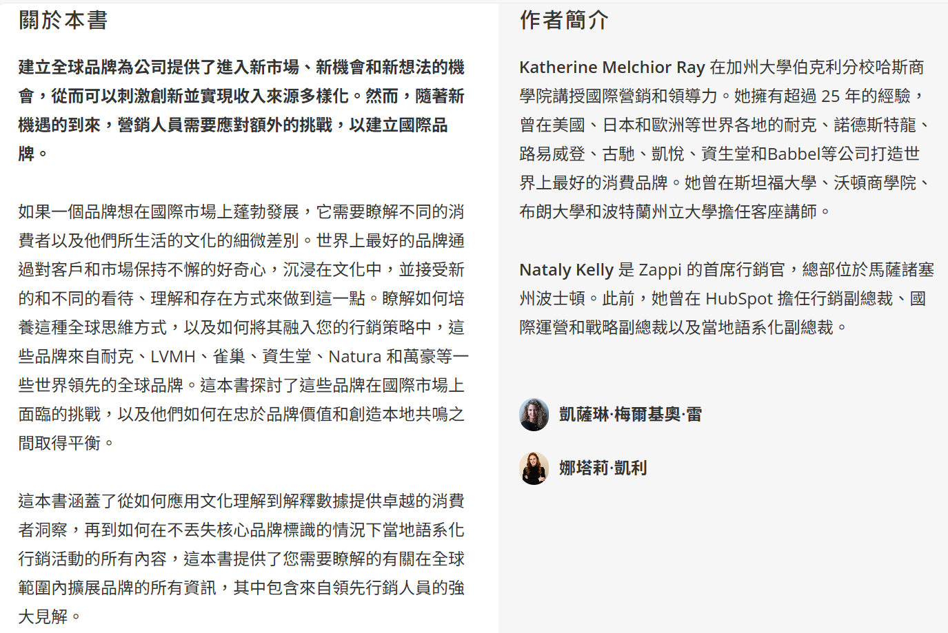


EAN：9781398620469



EAN：9781398620636
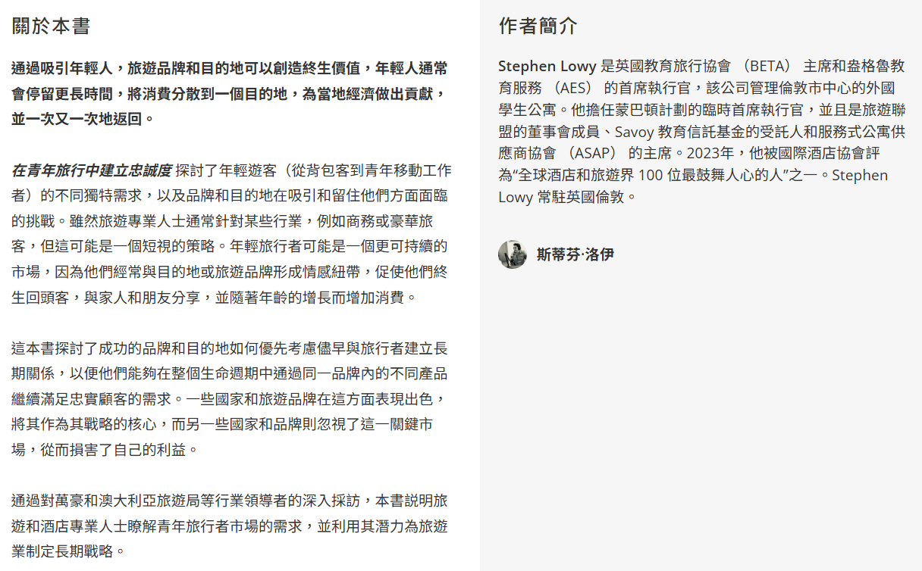


EAN：9781398620674
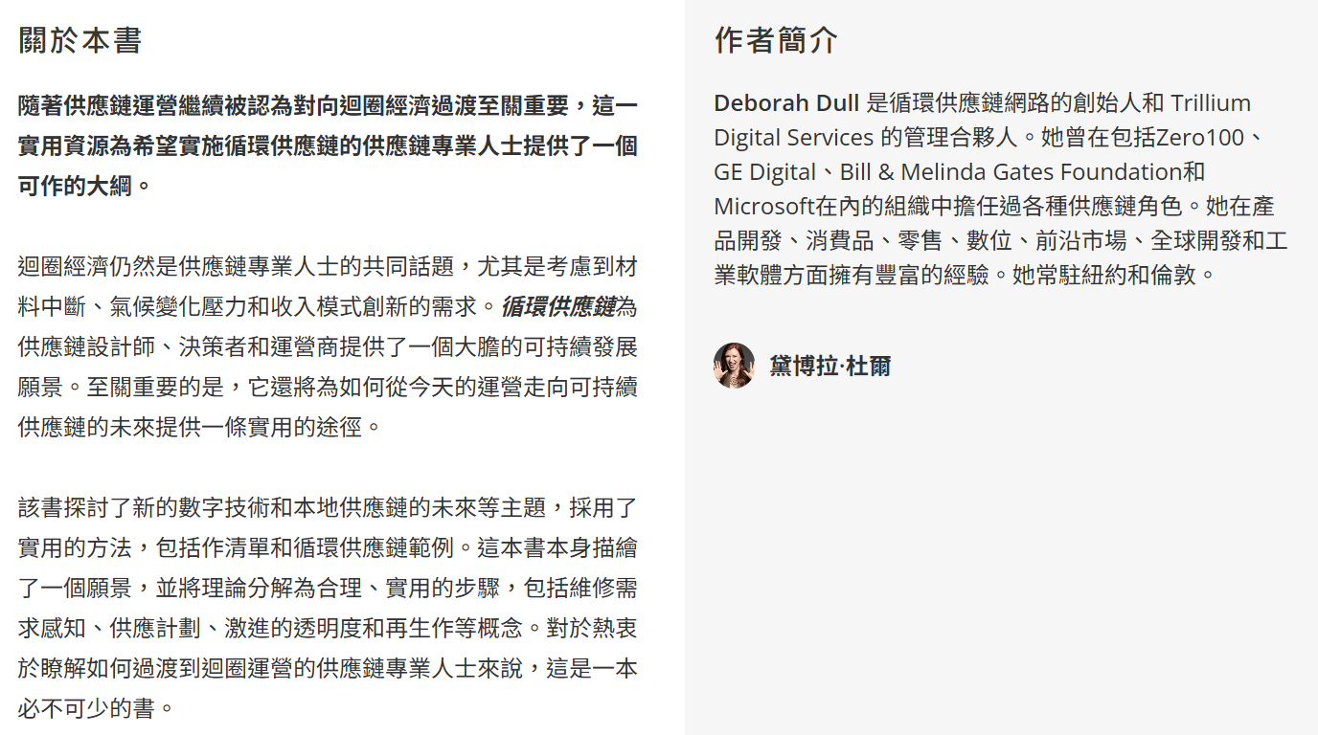

Kogan Page – Excel 附檔(KP Complete to August 25 by Subject)依主題、D欄位提供分類以方便使用。
- D 欄 main subject
  - AI, Digital & Technology (含 New Technology / Artificial Intelligence
  - Business Strategy (含 Strategy & Planning / Data Analysis & Research / Project Management
  - Environmental Management
  - Finance & Banking ( 含Fintech /Banking / Finance & Accounting
  - General Business Interest (含 Leadership / Creating Success /Personal Finance /Wellbeing at work/ Management / Business Stories/ Innovation /Entrepreneurship
  - Human Resources, Learning (含 Change Management/ Human Resources Management/ Talent Management & Recur /HR Analysis /Coaching/Learning & Development
  - Logistics, Supply Chain & Operation (含 Procurement /Supply Chain/ Operations
  - Marketing & Sales (含 Market Research/ Marketing Strategy/Digital Marketing/ Behavioural Marketing / PR & Communication/ Branding
  - Responsible Business (含 Equity, Diversity/ Sustainability
  - Risk & Compliance (含 Informantion & K /Cybersecurity / Risk Management
  - Skill & Careers (含 Workplace Skill /Specific Careers/ Job Seeking/
  - Tourism, Leisure & Hospitality (含 Hospitality /Tourism & Travel / Events..

