目錄
ASIAN STUDIES （亞洲研究） 2
BUSINESS AND MANAGEMENT （工商管理） 9
COMPUTER SCIENCE （計算機科學） 11
ECONOMICS & FINANCE （經濟金融） 12
ENGINEERING（工程學） 17
MATHEMATICS （數學） 20
MEDICINE （醫學） 30
PHYSICS （物理） 33
SOCIAL SCIENCES （社會科學） 38

ASIAN STUDIES （亞洲研究）
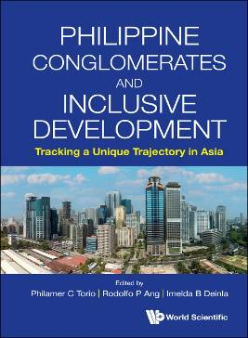 | Philippine Conglomerates and Inclusive Development  Tracking a Unique Trajectory in Asia  Edited by Philamer C Torio (Ateneo de Manila University, Philippines), Rodolfo P Ang (Ateneo de Manila University, Philippines), Imelda B Deinla (Ateneo de Manila University, Philippines)  306pp  978-981-12-6405-4 US$98 £90  Release Date (Asia): Sep 2024  Release Date (Rest of the World): Oct 2024  http://www.worldscientific.com/worldscibooks/10.1142/13076

"The editors and contributors to Philippine Conglomerates and Inclusive Development are to be congratulated on the publication of this timely and comprehensive volume. As in much of Asia, the presence and role of conglomerates in the Philippine economy and its political economy are perennial, often controversial, issues, politically and economically. Notwithstanding significant pro-competition reforms in recent years, the Philippine economy is still characterized by high levels of concentration. This will likely continue to be the case as it becomes a more service-oriented economy, which by definition means a larger share of 'non-tradable' activities which often have natural monopoly characteristics, and therefore invite (potentially politicized) regulatory intervention. The volume's comparative case studies are an added attraction. All in all, a most compelling read."
Dr Hal Hill
Professor Emeritus
Crawford School of Public Policy
The Australian National University

"The book contains insightful discussions on the dynamics of conglomerates and their economic significance relative to the Philippines' ongoing development narrative. Through comparative analysis, the authors perform two important tasks: (1) paint a clear picture of the conglomerates' role in nation-building, and (2) provide the Philippine government with actionable recommendations aimed at improving public-private sector collaboration that improves the lives of every Filipino."
Dr Arsenio M Balisacan
Socioeconomic Planning Secretary and Chief
National Economic and Development Authority

"The book maps how Philippine conglomerates have created jobs and uplifted lives, as well as some of their shortcomings, especially in comparison with Indonesia, Vietnam, and Korea. Coming on the heels of an administration that targeted big businesses, the start of a promising but 'complicated' relationship with a new one, and a global debate on capitalism, it's an important tool to help tycoons and policymakers work better together and give our people the same dividends and opportunities our neighbors are getting."
Mr Coco Alcuaz
Executive Director
Makati Business Club

Compared to their larger Asian counterparts, Philippine conglomerates have tracked a unique growth trajectory in the face of chronic poverty, economic inequality, and political conflict. While there are many studies about the zaibatsus of Japan and the chaebols of South Korea, there has been minimal research on Philippine conglomerates and their contributions to the successful turnaround of an economy that was once considered the region's perennial laggard.

In this collection of essays, the authors interrogate the relationship between conglomerates and inclusive development by highlighting the Philippine experience and comparing it with those of other Southeast and East Asian economies, notably Vietnam, Indonesia, and South Korea. Have Philippine conglomerates been central to the country's economic miracle? How have they contributed to the attainment of the government's inclusive development agenda? What can be learned from the successes and failures of other Asian conglomerates? These are the key themes this volume seeks to answer to shed light on how conglomerates have impacted the course of the country's economic development.

Key Features:
- This book shines a light on the experiences of the Philippine, Indonesian, Vietnamese, and South Korean conglomerates and notes important conditions under which they may—or may not—contribute to achieving inclusive development
- Who are these conglomerates and what strategies did they adopt to expand and consolidate their businesses? Which areas are they concentrated in? What regime types or regulatory environments are better suited to amplify their contributions to the public? What are their business models and what are their perspectives about genuine economic development? The chapters try to answer these questions while examining the nexus between governments and conglomerates as regards the attainment of the twin goals of economic growth and inclusive development

Contents: Introduction; In Search of Philippine Chaebols; Philippine Conglomerates: Their Role in Promoting Inclusive Development; Conglopolistic Competition in Small Emerging Economies; The Changing Nature of Philippine Conglomerates from a Political Economy Perspective; The Regional Expansion of Indonesian Conglomerates' Capital in Southeast Asia and the Exclusion of Development Project; Political Economic Determinants of Growth Acceleration: A Korea-Indonesia Comparative Study; Chaebols and Their Contributions to the South Korean Economy After the Asian Financial Crisis; Vietnam's Industrialization Ambitions: The Case of Vingroup and the Automotive Industry; Business Model Innovation towards Sustainability: Can Incumbent Conglomerates Contribute to Inclusive Development?; A Partnership in Crisis: The Case of Metro Manila's 2019 Water Crisis; Conglomerates and Inclusive Development: Perspectives from Four Prominent Filipino Tycoons;

Readership: Business professionals, policymakers, and scholars who are interested in finding out more about Asian conglomerates and their role in promoting economic growth and inclusive development. This will also appeal to readers interested in the economy and politics of the countries covered in this book.

 | Series on Asian Regional Cooperation Studies  Together for a Sustainable Peace of the South China Sea  The 20th Anniversary of Signing the Declaration on the Conduct of Parties in the South China Sea  Edited by Yanjun Guo (China Foreign Affairs University, China), Pou Sothirak (Cambodian Center for Regional Studies, Cambodia)  260pp  978-981-12-9602-4 US$88 £80  Release Date (Asia): Sep 2024  Release Date (Rest of the World): Oct 2024  http://www.worldscientific.com/worldscibooks/10.1142/13925

The year 2022 marked the 20th Anniversary of Declaration on the Conduct of Parties in the South China Sea (DOC). China and the ASEAN Member States issued a Joint Statement on this occasion. As another milestone consensus between ASEAN and China on the South China Sea, the Joint Statement recognises the benefits of having the South China Sea as a sea of peace, friendship and cooperation, appreciates the progress in the negotiations of the Code of Conduct in the South China Sea (COC), and reaffirms that the future adoption of the COC would further promote peace and stability in the region.

In a collaboration between the Cambodian Institute for Cooperation & Peace (CICP) and China Foreign Affairs University (CFAU), this book discusses respective and joint DOC- and COC-related experiences and practices for a sustainable peace of the South China Sea, from the perspective of both Chinese as well as ASEAN scholars.

Key Features:
- Recalling the Joint Statement of the 20th Anniversary of the DOC, the situation in the South China Sea has changed tremendously since the signing of the DOC. In this regard, the Joint Statement recognised the imperative of strengthened efforts and heightened goodwill towards the full and effective implementation of the DOC
- Structured on the theme of commemorating the 20th Anniversary of signing the DOC, this book project aims to present the experiences of negotiating and jointly implementing the DOC, inspired by diplomatic innovation and goodwill of both ASEAN countries and China. Furthermore, topics related to the South China Sea that are covered in this book will provide the perspectives of Chinese scholars as well as that of ASEAN scholars in each thematic section

Contents: Twenty Years of the Declaration on the Conduct of Parties in the South China Sea: China–ASEAN Relations; The DOC and China–ASEAN Maritime Cooperation; Substantive Issues Surrounding the COC Consultation: Forging a Legal Path Forward for the Negotiators; Historical Interaction of China–ASEAN Economic Cooperation and Security Governance: From the Perspective of DOC; Institutional Effectiveness and Mechanisms of the Implementation of the DOC; Road toward Sustainable Peace through the Declaration on the Conduct of Parties in the South China Sea; Provisional Arrangements under UNCLOS: A Comparative Analysis for the South China Sea Code of Conduct; The Underlying Economics of Conflict and Peace in the South China Sea; Together for a Sustainable Peace of the South China Sea: The 20th Anniversary of the Signing of the Declaration on the Conduct of Parties in the South China Sea; The DOC and Dispute Management in the South China Sea: Maintaining Dialogue, Maximizing Convergences; A Stronger DOC toward the Successful Completion of a Reliable COC: The ADMM in the Context of the South China Sea Issue; ASEAN, China, and the South China Sea; The DOC at 20: A Thai Perspective; ASEAN's 20 Years of Untiring Efforts to Engage China on the South China Sea: Lessons from the DOC and the Way Forward;

Readership: Advanced undergraduate and graduate students, researchers and practitioners in the disciplines of International Relations, Asian Politics / Society, Political Science/ Policy Studies/ Public Policy/ Security Studies as well as officials in the fields of diplomacy and international relations.

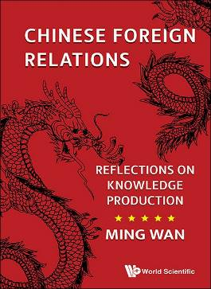 | Chinese Foreign Relations  Reflections on Knowledge Production  By Ming Wan (George Mason University, USA)  294pp  978-1-80061-591-5 US$98 £90  Release Date (Asia): Sep 2024  Release Date (Rest of the World): Oct 2024  http://www.worldscientific.com/worldscibooks/10.1142/q0469

With China's global ascendancy, Chinese foreign policy has become a popular area of studies for scholars around the world. Rather than simply contributing to this subject, this book sets out to reflect on the field itself, using as samples some of the author's previous work, both published and unpublished, covering different areas of Chinese foreign policy and adopting different approaches. In doing so, it examines how knowledge about Chinese foreign policy has evolved, focusing on areas such as traditions, values, perspectives and regionalism.

The field of Chinese foreign policy has evolved along with international relations and foreign policy analysis. The quality of the studies of specific topics has generally been high thanks to the competitive and extensive nature of academic research and exchange, despite a perceived failure to predict Beijing's current assertive foreign policy orientation. Looking forward, this book reflects on how changing trends in a number of key areas — a shift in thinking about opposition research, an excessive focus on national security, narrowing of academic exchange, and increasingly limited access between China and the West — threaten to lower the quality in future Chinese foreign policy studies in Western countries.

Key Features:
- Of 11 chapters, four are from previously published works, and seven (including the introduction) are newly written
- Not a straightforward book on foreign policy — it analyses and reflects on the field itself

Contents: Introduction; Chinese Traditions: China's Political Evolution from Ancient Times to the Opium War; China's Political Evolution from the Opium War to Present; A First Century BC Chinese Strategic Debate; Chinese Sovereign Debt in 1853–1914; Values and Perspectives: Human Rights in US–China Relations; China in Africa in the 2000s: Beyond Oil and Human Rights; Chinese Perspectives on Backlash to China Rise; Regionalism: East Asian Regionalism and Human Rights; The Domestic Political Economy of China's Regionalism; The Shanghai Cooperation Organization;

Readership: This book is targeted towards the academic and policy community focusing on China, Asia, foreign policy and international relations. It would also be suitable reading for graduate level courses in these subject areas.

BUSINESS AND MANAGEMENT （工商管理）
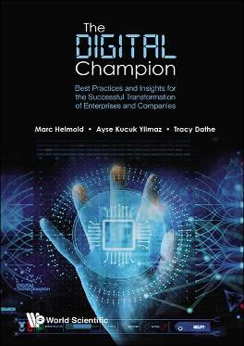 | The Digital Champion  Best Practices and Insights for the Successful Transformation of Enterprises and Companies  By Marc Helmold (IU Internationale Hochschule Berlin, Germany), Ayse Kucuk Yilmaz (Eskişehir Teknik Üniversitesi, Turkey), Tracy Dathe (Macormedai University, Germany)  350pp  978-981-12-9305-4 US$138 £125  Release Date (Asia): Sep 2024  Release Date (Rest of the World): Oct 2024  http://www.worldscientific.com/worldscibooks/10.1142/13835

Digital transformation, AI and the use of human-like machines are among the most important social and economic developments of our time. In addition to applications and concepts of digitalization and artificial intelligence, this book describes how companies can implement strategies to successfully transform a company into a digital champion. In addition, numerous practical examples in the areas of supply chain management, production, sustainability and education are presented.

Key Features:
- This book is unique in providing lean principles for the successful digital transformation and artificial intelligence (AI) of enterprises and companies(AI)
- Digital Transformation can be successfully done with tools like AI, Big Data, Realities, (remove comma) and Machine Learning
- Ideal Book for a wide Target Group: Practitioners in IT, Operations, Quality, Procurement, Logistics, SCM, Finance, IT or HR across the value chain
- This book caters to a wide audience including practitioners in IT, Operations, Quality, Procurement, Logistics, SCM, Finance, IT or HR across the value chainrs

Contents: Digitalization and Artificial Intelligence (AI); Trends in the Area of Digitalization and AI; Transformation and Outperformance in Digitalization and AI; Strategic and cultural Digitilization and AI Transformation; Industry 4.0 and Internet of Things (IoT); Extended Realities (XR); Cybersecurity and Cyberphysical Systems (CPS); Smart Factory; Blockchain, Digital Currencies, Cryptocurrencies and Bitcoins; Big Data Management; Nanotechnology; Robotics and Artificial Intelligence (AI); ChatGPT; Work and New Leadership as drivers of digital applications; Paperless and Lean Office Environment as the Workplace of Future; Digitalization and AI in Lean Management and Kaizen; Digitalization and AI Applications in Supply Chain Management (SCM); Use of AI in HR and Interviews; Digitalization and AI Negotiations; Digitalization and AI in Quality Management (QM); Digitalization and AI as Drivers for ESG and Sustainability; Autonomous Driving and AI in Mobility; Digitalization and Artificial Intelligence (AI) in Healthcare; Digital Concepts in Education; Digitalization and AI Outlook;

Readership: Undergraduates, graduates and MBA students in Data Science, AI, Operations, and Business, as well as managers and experts across the value chain.

COMPUTER SCIENCE （計算機科學）
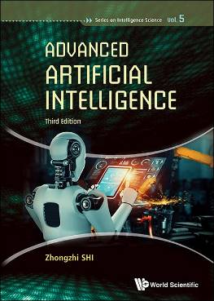 | Series on Intelligence Science - Volume 5  Advanced Artificial Intelligence  3rd Edition  By Zhongzhi Shi (Chinese Academy of Sciences, China)  384pp  978-981-12-9398-6 US$148 £135  Release Date (Asia): Sep 2024  Release Date (Rest of the World): Oct 2024  http://www.worldscientific.com/worldscibooks/10.1142/13861

This third edition comprehensively captures the cutting-edge research achievements of AI. Topics are thoroughly revised and updated, presenting the latest techniques and strategies to address the impending challenges facing computer scientists today.

The useful reference text benefits professionals, academics, researchers, senior and graduate students in the information field and related tertiary specialties.

Contents: Introduction; Logic Foundation; Causal Reasoning; Game Theory; Statistical Learning; Deep Learning; Reinforcement Learning; Transfer Learning; Federated Learning; Artificial General Intelligence; Crowd Computing; Artificial Intelligence for Science; Bibliography;

Readership: Researchers, professionals, academics and graduate students in artificial intelligence, machine learning and pattern recognition.

ECONOMICS & FINANCE （經濟金融）
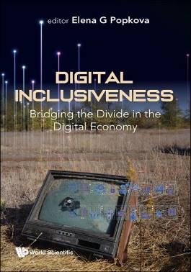 | Advances in Entrepreneurial Economics and Sustainable Development - Volume 2  Digital Inclusiveness  Bridging the Divide in the Digital Economy  Edited by Elena G Popkova (Institute of Scientific Communications, Russia))  320pp  978-981-12-7081-9 US$118 £110  Release Date (Asia): Sep 2024  Release Date (Rest of the World): Oct 2024  http://www.worldscientific.com/worldscibooks/10.1142/13264

Digital Inclusiveness has ignited a conversation across the world. It delves into the world of digital economy as a modern form of organization for economic systems.

The chapters transcend knowledge about the essence of digital inclusiveness over to the human right facets of the online environment. The book also offers an understanding of digital literacy, technological barriers, cybersecurity and digital entrepreneurship.

What is the digital divide? Digital inclusiveness considers a myriad of issues pertaining to this topic. It narrows down to the era of the pandemic, lockdown and homeworking for the study of digital divide. The ways of addressing it are discussed l whilst offering promising solutions to overcome it. It will give you a complete understanding to support digital inclusiveness and empower society to work with digital technologies.

With a fair and equitable distribution, the book will open the door to online information management systems. As a manifestation of global digital inclusion, these high-tech markets are seen as the future of international trade.

Key Features:
- Research materials are accompanied by numerous examples from international practice, which will enrich the learning experience of students
- The book uses a progressive methodology, covering both qualitative (case studies, surveys) and quantitative (correlation analysis, construction of economic and mathematical models using the method of regression analysis) methods. This makes it possible to comprehensively highlight the current lack of inclusivity in the digital economy and how to address it
- The book offers comprehensive and applied recommendations for mitigating and overcoming the contradictions of the digital economy through the management of digital inclusiveness initiatives
- The book is multidisciplinary — it views the digital economy as a scientific concept with broad boundaries covering finance, education, health economics, business and management (entrepreneurial economics), and public administration. Multidisciplinarity based on the systems approach will allow the book to systematically reflect on the many facets of digital inclusiveness as a priority for the equitable development of the digital economy
- Special attention in the book (in a special chapter) is paid to the unique experience of the COVID-19 pandemic and crisis that has highlighted many problems and features of the digital divide in the era of lockdowns while also offering prospects for overcoming them

Contents: Digital Inclusiveness for Sustainable Development; Bridging the Digital Divide in the Era of Lockdowns; The Contribution of Digital Inclusiveness to the Growth of Quality of Life; Public Infrastructure as the Basis for Digital Inclusiveness; Digital Economy and its Inclusiveness; Digital Inclusiveness in Entrepreneurship through the Lens of Technological Barriers of Markets; The Inclusive Approach to HR Management; Development, Accessibility and Use of Technologies according to Inclusive Practices; AI and Machine Learning in Inclusive Development to Personalize User Experience and increase Digital Literacy; Regulation and Enforcement of Human Rights, Transparency, Data Protection, Ethics of Technology and Data Use in the Context of Digital Transformation; Digital Literacy and Its Value for Modern Society's Inclusiveness; Risk Management of Developments Based on Advanced Technologies and Errors in Working with Data that Increase Discrimination and the Digital Divide; The Culture of Inclusiveness as an Engine of Innovation and a Factor of Effective Decision-Making; Cybersecurity as the Condition of Digital Inclusiveness; Digital Inclusiveness and Spatial Inequality; Data Management during the provision of Digital Inclusiveness; Information Society as an Inclusive Social Environment; E-Government and its Value for Digital Inclusiveness; International Trade in High-Tech Markets as a Manifestation of the Global Digital Inclusiveness;

Readership: Scholars interested in digital economy courses. Scholars in the fields or disciplines such as Finance, Education, Health Economics, Business and Management, Public Administration.

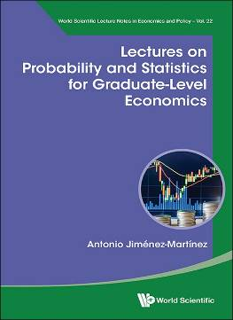 | World Scientific Lecture Notes in Economics and Policy - Volume 22  Lectures on Probability and Statistics for Graduate-Level Economics  By Antonio Jiménez-Martínez (Centro de Investigación y Docencia Económicas, Mexico)  242pp  978-981-12-9257-6 US$88 £80  978-981-12-9282-8(pbk) US$48 £45  Release Date (Asia): Sep 2024  Release Date (Rest of the World): Oct 2024  http://www.worldscientific.com/worldscibooks/10.1142/13824
Sound knowledge of rigorous probability and statistics methods is essential to pursue graduate studies in economics. These sorts of tools are largely required to conduct research in modern fields of economics such as economic theory, empirical economics, experimental economics, or data science for economics.
These notes provide an intuitive roadmap to navigate graduate-level courses in mathematical probability and statistics for economists. Each chapter presents questions prevalent on each topic and lays out the state-of-the-art theoretical frameworks used to address such questions. The book offers a diverse array of solved examples to help gain intuitions on abstract concepts, as well as unsolved exercises to stimulate the readers' training in such concepts. The book presents the theoretical side of probability and statistics in a rather concise way and stresses the importance of motivating examples and observations.
Key Features:
- Emphasis on the sorts of tools that are required to conduct research in economics. The concepts developed in the book can be readily applied to address questions of interest in economics
- Rigorous theoretical ideas of probability theory, such as concepts of measure theory, are presented in intuitive ways with the aid of solved examples
- A practical and concise approach is taken to help readers directly obtain the sorts of tools needed to answer questions of interest in graduate studies in economics
Contents: Probability: Probability Models; Random Variables; Moments of Distributions; Moments Generating and Characteristic Functions; A Few Notions of Combinatorics; Statistical Inference: Convergence of Probability Distributions; Parametric Point Estimation; Theories of Hypothesis Testing; Theories of Interval Estimation;
Readership: Graduate students and instructors of courses in probability and statistics in graduate economics programs.

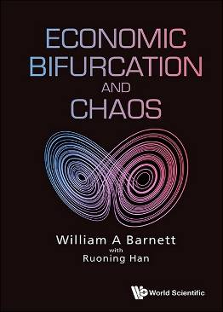 | Economic Bifurcation and Chaos  By William A Barnett (University of Kansas, USA)  With Ruoning Han (Whitman College, USA)  680pp  978-981-12-9365-8 US$178 £165  Release Date (Asia): Sep 2024  Release Date (Rest of the World): Oct 2024  http://www.worldscientific.com/worldscibooks/10.1142/13852
Economic Bifurcation and Chaos provides a unified presentation of the contributions to the literature on economic bifurcation, nonlinear dynamics, and chaos by William A Barnett and his coauthors. The span of the research begins in 1988 with Barnett's initial finding of chaos in economic data. The book continues with subsequent findings of bifurcation in all dynamical macroeconomic models so far tested by Barnett and his coauthors. The research covered extends over 3 decades to his recent findings of Shilnikov chaos in New Keynesian models of the UK and US economies. While methodology for testing for bifurcation, nonlinear dynamics, and chaos are fundamental to the research, the book's ultimate objectives focus on implications for robustness of dynamical inferences and implications for policy.

Bifurcation subsets are found stratifying the parameter space of all tested macroeconomic models, with confidence regions of parameter estimates crossing the boundaries between those subsets. A robustness problem results from policy simulations conducted only at point estimates of model parameters. Such simulations should be conducted at various locations throughout the confidence region to explore the dynamical implications of such models.

A more dramatic result is acquired in the special case of New Keynesian models during periods of active Taylor rule setting of short-term interest rates. That policy, without the imposition of a long run transversality condition, bifurcates the economy's dynamics to Shilnikov chaos, implying unintended long run downward drift of interest rates within the Shilnikov fractal attractor set. To control the drift, there needs to be a second policy instrument focused on the long run.

Key Features:
- This book contains an authoritative presentation of how the literature on economic bifurcation and chaos has evolved over the past thirty years
- The book clearly identifies the problems encountered along the way, how they were overcome, and where the state of the art now lies

Contents: Foreword; Introduction to Volume; Bifurcations in Macroeconomic Models; Nonlinear and Complex Dynamics in Real Systems; The Aggregation-Theoretic Monetary Aggregates are Chaotic and Have Strange Attractors: An Econometric Application of Mathematical Chaos; Robustness of Nonlinearity and Chaos Tests to Measurement Error, Inference Method, and Sample Size; Has Chaos Been Discovered with Economic Data?; A Single-Blind Controlled Competition among Tests for Nonlinearity and Chaos; Empirical Assessment of Bifurcation Regions within New Keynesian Models; Singularity Bifurcation; Existence of Singularity Bifurcation in an Euler-Equations Model of the United States Economy: Grandmont was Right; Hopf Bifurcation in the Clarida, Gali, and Gertler Model; An Analytical and Numerical Search for Bifurcations in Open Economy New Keynesian Models; Monetary Policy and Determinacy: An Inquiry into Open Economy New Keynesian Macrodynamics; Capital Control, Exchange Rate Regime, and Monetary Policy: Indeterminacy and Bifurcation; Bifurcation Analysis of an Endogenous Growth Model; Stability Analysis of Uzawa-Lucas Endogenous Growth Model; Non-Robust Dynamic Inferences from Macroeconometric Models: Bifurcation Stratification of Confidence Regions; Robustness of Inferences to Singularity Bifurcation; Shilnikov Chaos, Low Interest Rates, and New Keynesian Macroeconomics; Is Policy Causing Chaos in the United Kingdom?; Controlling Chaos in New Keynesian Macroeconomics;

Readership: Advanced undergraduate and graduate students, researchers, and practitioners in the fields of economics and finance, as well as scientists in physical sciences and engineering who are interested in methodological developments and applications of nonlinear dynamics, bifurcation, and chaos in economics.

ENGINEERING（工程學）
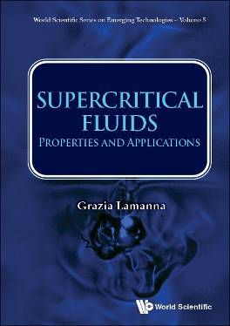 | World Scientific Series on Emerging Technologies: Avram Bar-Cohen Memorial Series  Supercritical Fluids  Properties and Applications  By Grazia Lamanna (University of Stuttgart, Germany)  300pp  978-981-12-7075-8 US$108 £100  Release Date (Asia): Sep 2024  Release Date (Rest of the World): Oct 2024  http://www.worldscientific.com/worldscibooks/10.1142/13262
This unique compendium revises the most recent thermodynamic theories of supercritical fluids, focusing on the dynamic crossover and the role of thermodynamic properties in controlling this crossover.

The volume also critically discusses different transition criteria to predict the onset of single-phase (diffusive) mixing and applies them to transcritical droplets and jets. The book overviews the different types of disintegration regimes and the conditions under which phase separation made be observed, even for supercritical injection conditions.

This useful reference text benefits professionals, researchers, academics and graduate students in the fields of aerospace engineering, applied physics, chemical engineering and energy studies.

Contents: Introduction; Supercritical Fluids: Structural and Dynamical Properties; High-Pressure Disintegration Regimes: An Overview; Transition Criteria for the Onset of Diffusive Mixing; Experimental Facilities and Diagnostic Methods; The Role of Bulk Viscosity at High-Pressure; Droplet Evaporation at High-Pressure; High-Pressure Disintegration Regimes and their Application; Conclusions;

Readership: Researchers, professionals, academics, undergraduate and graduate students in aerospace engineering, applied physics and chemical engineering.

 | Selected Topics in Electronics and Systems - Volume 68  Fundamental and Applied Problems and Solutions in Terahertz-related Devices and Technologies  Edited by Taiichi Otsuji (Tohoku University, Japan), Wojciech Knap (Polish Academy of Sciences, Poland), Maxim Ryzhii (University of Aizu, Japan), Michael Shur (Rensselaer Polytechnic Institute, USA)  200pp  978-981-12-8680-3 US$88 £80  Release Date (Asia): Sep 2024  Release Date (Rest of the World): Oct 2024  http://www.worldscientific.com/worldscibooks/10.1142/13691

The unique compendium provides a broad up-to-date perspective on THz science and technology — enabling technology for 6G communication, detection of biological and chemical hazardous agents, cancer detection, monitoring of industrial processes and products, and detection of mines and explosives.

Contributed by eminent researchers, this useful reference text links THz science and THz applications and combines a detailed review of the state-of-art with the most recent breakthrough research results.

Readership: Researchers, professionals, academics and graduate students in electrical and electronic engineering, nanotechnology and condensed matter physics.

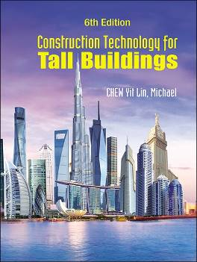 | Textbook  Construction Technology for Tall Buildings  6th Edition  By Michael Yit Lin Chew (National University of Singapore, Singapore)  600pp  978-981-12-9437-2 US$188 £175  978-981-12-9392-4(pbk) US$98 £90  Release Date (Asia): Sep 2024  Release Date (Rest of the World): Oct 2024  http://www.worldscientific.com/worldscibooks/10.1142/13859

In this 6th edition, the text and illustrations of every chapter are thoroughly revised to present the latest technologies, methodologies, and processes for the construction of tall buildings, from foundation, basement, and superstructure to roof. Contemporary sustainability concerns, as well as the latest regulations and standards, are highlighted.

The target readers are practitioners and students in the building and construction professions including architecture, engineering, infrastructure and project management, building and construction management, real estate, quantity surveying and land surveying.

Contents: Assembly of Buildings; Workplace Safety and Health; Site Investigation; Foundation; Basement; Materials Handling and Mechanisation; Wall and Floor; External Wall; Roof;

Readership: Undergraduate students and practitioners in architecture, civil engineering, building, real estate and urban planning.

MATHEMATICS （數學）
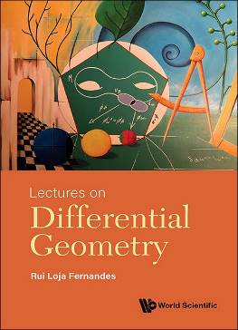 | Textbook  Lectures on Differential Geometry  By Rui Loja Fernandes (University of Illinois Urbana-Champaign, USA)  300pp  978-981-12-5264-8 US$98 £90  978-981-12-5336-2(pbk) US$68 £65  Release Date (Asia): Sep 2024  Release Date (Rest of the World): Oct 2024  http://www.worldscientific.com/worldscibooks/10.1142/12733

This book presents a concise introduction to differential geometry. It is aimed at advanced undergraduate students and first year graduate students who wish to have a basic solid knowledge of the subject, and it can serve as a starting point for more advanced reading. The book is organized into lectures, so it can easily be used as a textbook for a beginning graduate-level course in differential geometry.

Key Features:
- The book is much more concise than other textbooks in differential geometry, but it still gives a clear, detailed and careful discussion of the most important topics necessary to grasp the subject
- Some topics, such as the Godement criteria for quotients, are usually not discussed in other textbooks
- Each lecture ends with a list of homework problems, carefully chosen to complete the topics covered in the lecture

Contents: Basic Concepts: Manifolds as subsets of Euclidean Space; Abstract Manifolds; Manifolds with Boundary; Partitions of Unity; The Tangent Space; The Differential; Immersions, Submersions and Submanifolds; Embeddings and Whitney's Theorem; Foliations; Quotients; Lie Theory: Vector Fields and Flows; Lie Bracket and Lie Derivative; Distributions and the Frobenius Theorem; Lie Groups and Lie Algebras; Integrations of Lie Algebras; The Exponential Map; Groups of Transformations; Differential Forms: Differential Forms and Tensor Fields; Differential and Cartan Calculus; Integration on Manifolds; de Rham Cohomology; The de Rham Theorem; Homotopy Invariance and Mayer-Vietoris Sequence; Computations in Cohomology; The Degree and the Index; Fiber Bundles: Vector Bundles; The Thom Class and the Euler Class; Pullbacks of Vector Bundles; The Classification of Vector Bundles; Connections and Parallel Transport; Curvature and Holonomy; The Chern-Weil homomorphism; Characteristic Classes; Fiber Bundles; Principal Fiber Bundles;

Readership: For advanced undergraduate and beginning graduate level courses in Mathematics/Physics on Differential Geometry.

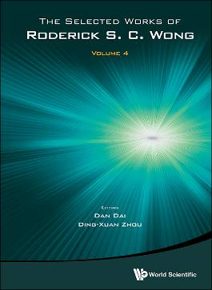 | The Selected Works of Roderick S C Wong  Volume 4  Edited by Dan Dai (City University of Hong Kong, Hong Kong), Ding-Xuan Zhou (The University of Sydney, Australia)  550pp  978-981-12-9085-5 US$168 £155  Release Date (Asia): Sep 2024  Release Date (Rest of the World): Oct 2024  http://www.worldscientific.com/worldscibooks/10.1142/13778
This book represents a distinguished collection of research papers authored by the esteemed Professor Roderick Wong, a globally recognized mathematician, and a pioneer in the field of applied mathematics. His brilliant academic journey has spanned across different continents, including North America and Hong Kong.

Throughout his illustrious career, Professor Wong has consistently made profound and impactful contributions that have significantly advanced the domain of applied mathematics. His exceptional achievements have been widely acknowledged and celebrated through a multitude of prestigious awards and honors. Notably, he was bestowed with the esteemed title of Fellow of the Royal Society of Canada in 1993, recognized as a foreign member of the Academy of Sciences of Turin (Italy) in 2001, and honored with the Chevalier dans l'Ordre National de la Légion d'Honneur by the French government in 2004. Additionally, Professor Wong's remarkable accomplishments have led to his membership in the European Academy of Sciences in 2007. These accolades serve as a testament to his exemplary contributions to the field.

The book, showcasing Professor Wong's research papers, not only reflects his immense expertise and profound insights but also serves as a tribute to his remarkable achievements.

It is an invaluable resource for researchers and graduate students seeking to explore the frontiers of applied analysis, providing them with a rare opportunity to explore the intellectual legacy of a true luminary in the field.

Key Features:
- This book provides a unique viewpoint of many important topics of applied mathematics from deep analysis. Such a viewpoint is needed for a general reader to understand the spirit of applied analysis and its applications in various fields of science and engineering
- Professor Wong's research papers covers a broad spectrum of topics, encompassing asymptotic analysis, perturbation methods, special functions and orthogonal polynomials, integral transforms, integral equations, and ordinary differential equations
- These papers not only enjoy widespread appreciation but have also played a pivotal role in shaping and influencing numerous research areas within the field of applied mathematics
- By perusing the pages of this book, researchers and graduate students will have the invaluable opportunity to explore a vast reservoir of knowledge and gain profound insights, making it an indispensable resource for those working in the realm of applied analysis

Readership: Academics, researchers, post-graduate students, undergraduate students, mathematicians, physicists, engineers.

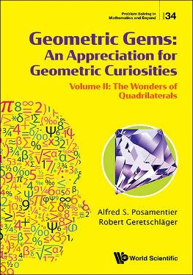 | Study Guide  Problem Solving in Mathematics and Beyond  Geometric Gems: An Appreciation for Geometric Curiosities  Volume II: The Wonders of Quadrilaterals  By Alfred S Posamentier (City University of New York, USA), Robert Geretschläger (University of Graz, Austria)  320pp  978-981-12-9144-9 US$88 £80  978-981-12-9229-3(pbk) US$38 £35  Release Date (Asia): Sep 2024  Release Date (Rest of the World): Oct 2024  http://www.worldscientific.com/worldscibooks/10.1142/13792

Our physical world is embedded in a geometric environment. Plane geometry has many amazing wonders beyond those that are briefly touched on at school. The quadrilateral, one of the basic instruments in geometry, has a plethora of unexpected curiosities. The authors present these in an easily understood fashion, requiring nothing more than the very basics of school geometry to appreciate these curiosities and their justifications or proofs.

The book is intended to be widely appreciated by a general audience, and their love for geometry should be greatly enhanced through exploring these many unexpected relationships in geometry. Geometric Gems is also suitable for mathematics teachers, to enhance the education of their students with these highly motivating quadrilateral properties.

Key Features:
- Getting to love geometry by experiencing amazing curiosities involving quadrilaterals
- Each curiosity is accompanied by a clear and detail diagram
- Problems are presented, and their solutions are usually worked through in clear steps

Contents: Introduction; Geometric Curiosities; Proofs of the Geometric Curiosities; A Mathematics Toolbox;

Readership: The book is intended for the general readership, mathematics teachers, and mathematicians interested in extending their appreciation for geometry.

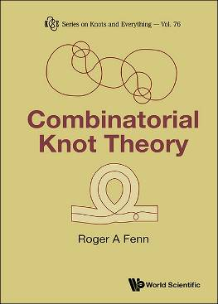 | Series on Knots and Everything - Volume 76  Combinatorial Knot Theory  By Roger A Fenn (University of Sussex, UK)  180pp  978-981-12-9272-9 US$78 £70  Release Date (Asia): Sep 2024  Release Date (Rest of the World): Oct 2024  http://www.worldscientific.com/worldscibooks/10.1142/13826
A classic knot is an embedded simple loop in 3-dimensional space. It can be described as a 4-valent planar graph or network in the horizontal plane, with the vertices or crossings corresponding to double points of a projection. At this stage we have the shadow of the knot defined by the projection. We can reconstruct the knot by lifting the crossings into two points in space, one above the other. This information is preserved at the vertices by cutting the arc which appears to go under the over crossing arc. We can then act on this diagram of the knot using the famous Reidemeister moves to mimic the motion of the knot in space. The result is classic combinatorial knot theory. In recent years, many different types of knot theories have been considered where the information stored at the crossings determines how the Reidemeister moves are used, if at all.
In this book, we look at all these new theories systematically in a way which any third-year undergraduate mathematics student would understand. This book can form the basis of an undergraduate course or as an entry point for a postgraduate studying topology.
Key Features:
- The contents of this book are unique and only found scattered in research papers
- No existing books have such a comprehensive approach to knot theory via projections
- The author is a well-known expert in this field
Contents: Introduction; Basic Concepts; Generalised Knot Theories; Chord Diagrams; Virtual Crossings and Virtual Knots; Max Newman's Proof Technique; Generalised Braids; Alexander and Markov Theorems; Unfinished Business from Chapter 7; The Sorting Method: Invariants; Appendices: The Homflypt Polynomial; Categories; Codes for Curves; Examples of Planar Doodles; Index; Bibliography;
Readership: Textbook or for self-study for advanced university undergraduate and postgraduate courses on topology. Researchers who wish to extend their knowledge on knot theory.

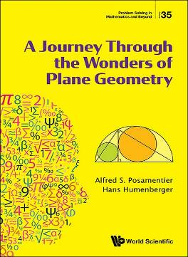 | Study Guide  Problem Solving in Mathematics and Beyond  A Journey Through the Wonders of Plane Geometry  By Alfred S Posamentier (City University of New York, USA), Hans Humenberger (University of Vienna, Austria)  300pp  978-981-12-9284-2 US$98 £90  Release Date (Asia): Sep 2024  Release Date (Rest of the World): Oct 2024  http://www.worldscientific.com/worldscibooks/10.1142/13828

Geometry is often seen as one of the most beautiful aspects of mathematics. This beauty is probably a result of the fact that one can "see" this aspect of mathematics. Most people are exposed to the very basic elements of geometry throughout their schooling, concentrated in the secondary school curriculum. High schools in the United States offer one year of concentrated geometry teaching, allowing students to observe how a mathematician functions, since everything that is accepted beyond the basic axioms must be proved. However, as the course is only one year long, a great amount of geometry remains to be exposed to the general audience. That is the challenge of this book, wherein we will present a plethora of amazing geometric relationships.

We begin with the special relationship of the Golden Ratio, before considering unexpected concurrencies and collinearities. Next, we present some surprising results that arise when squares and similar triangles are placed on triangle sides, followed by a discussion of concyclic points and the relationship between circles and various linear figures. Moving on to more advanced aspects of linear geometry, we consider the geometric wonders of polygons. Finally, we address geometric surprises and fallacies, before concluding with a chapter on the useful concept of homothety, which is not included in the American year-long course in geometry.

Key Features:
- The book provides a view of geometry that has been largely neglected in high school
- The book is presented in a very reader friendly way
- The book offers amazing insights into the geometric world that will bring readers to love the subject
- The book also presents curiosities and fallacies that are often neglected in viewing geometry, along with thorough explanations

Contents: Introduction; The Golden Ratio in Geometry; Unexpected Concurrencies; Unexpected Collinearities; Squares on Triangle Sides; Similar Triangles on Triangle Sides; Discovering Concyclic Points; Circle Wonders; Polygons and Polygrams; Geometric Surprises; Geometric Fallacies; Homothety/Similarity and Applications;

Readership: This book is suitable for secondary/high school level students and teachers, as well as a general readership, particularly those interested in bridging the gaps in their knowledge of geometry.

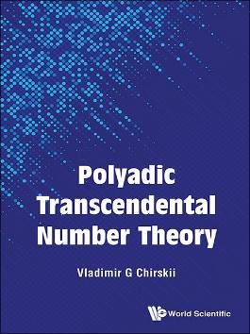 | Polyadic Transcendental Number Theory  By Vladimir G Chirskii (Lomonosov Moscow State University, Russia)  200pp  978-1-80061-588-5 US$88 £80  Release Date (Asia): Sep 2024  Release Date (Rest of the World): Oct 2024  http://www.worldscientific.com/worldscibooks/10.1142/q0468

The existence of transcendental numbers was first proved in 1844, by Joseph Liouville. Advances were made by Charles Hermite, proving the transcendence of the number e, and Ferdinand von Lindemann, proving the transcendence of the number π. The consequence of these discoveries was the negative solution of the problem of squaring the circle, which has stood for many years. In the 20th century, the theory of transcendental numbers developed further, with general methods of investigating the arithmetic nature of various classes of numbers. One of these methods is the Siegel–Shidlovskii method, previously used for the so-called E- and G-functions.

Polyadic Transcendental Number Theory outlines the extension of the Siegel–Shidlovskii method to a new class of F-series (also called Euler-type series). Analogues of Shidlovskii's famous theorems on E-functions are obtained. Arithmetic properties of infinite-dimensional vectors are studied, and therefore elements of direct products of rings of integer p-adic numbers are considered. Hermite–Padé approximations are used to investigate the values of hypergeometric series with algebraic irrational parameters. Moreover, the book describes how to use Hermite–Padé approximations to obtain results on the values of hypergeometric series with certain transcendental (polyadic Liouville) parameters. Based on quite recent results, this book contains indications of promising areas in a new field of research. The methods described allow readers to obtain many new results.

Key Features:
- Analogs of A B Shidlovskii's famous theorems on E-functions are obtained
- The book describes how to use Hermite–Padé approximations to obtain results on the values of hypergeometric series with certain transcendental (polyadic Liouville) parameters
- The book is based on quite recent results and contains indications of promising areas in a new field of research
- Contains a description of the methods and areas in which you can conduct independent research

Contents: Introduction; Polyadic Numbers; F-series; Generalization of Siegel–Shidlovskii's Method for F-series; Euler's Factorial Series and Direct Generalizations; Arithmetic Properties of Polyadic Series with Periodic Coefficients; Hypergeometric F-series; Arithmetic Properties of Generalized Hypergeometric Series with Algebraic Irrational Coefficients; Arithmetic Properties of Generalized Hypergeometric Series with Transcendental Polyadic Parameters; Transcendence of p-adic Values of Generalized Hypergeometric Series with Transcendental Polyadic Parameters;

Readership: The book is intended for specialists and graduate students studying the theory of transcendental numbers.

MEDICINE （醫學）
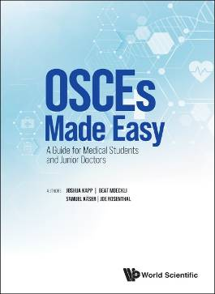 | Medical Handbook  Recommended for Bookshops  OSCEs Made Easy  A Guide for Medical Students and Junior Doctor  By Joshua Kapp (University of Zurich, Switzerland), Beat Moeckli (University of Geneva, Switzerland), Samuel Käser (Solothurn Hospital, Switzerland), Joe Rosenthal (University College London, UK)  412pp  978-1-80061-184-9 US$98 £90  978-1-80061-203-7(pbk) US$58 £55  Release Date (Asia): Sep 2024  Release Date (Rest of the World): Oct 2024  http://www.worldscientific.com/worldscibooks/10.1142/q0349
OSCEs Made Easy is tailored for undergraduate medical students and postgraduate medical trainees. It is a practical guide on how to prepare rigorously and systematically for OSCEs, and to secure yourself a high scoring result. A compilation of personal revision notes, combined with stories about what worked well, the objective of this book is to provide every final year medical student with the information we wish we had known going into OSCE revision. For what it is worth, all of us contributing to this book passed the OSCEs with distinctions!
This book is not just an exam crammer. It is also an excellent resource for the first years on the clinical wards challenged by a complex patient on the cardiology ward, or for those who forgot how to properly examine a patient with a neurological complaint in the emergency room. The reader of this book will be provided with the resources to take a focused history, perform a proper examination, prescribe and do basic procedures.
Key Features:
- A comprehensive guide to the OSCEs that addresses all possible scenarios
- Written by students who, through their preparation, performed exceedingly well on the OSCEs
- A compact, yet comprehensive guide to history taking, clinical exam, practical skills and prescribing for the first clinical years on the wards
Contents: Dedication; Preface; About the Authors; Non-Technical Advice for Exam Preparation; History Taking; Clinical Examination; Focused History & Patient Management; Explaining Procedures; Communication Skills; Interpreting X-Rays; Practical Skills; Prescribing;
Readership: Medical students preparing for final year exams and junior doctors starting their clinical careers.

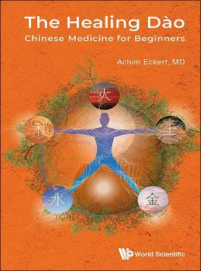 | Textbook  Recommended for Bookshops  The Healing Dào  Chinese Medicine for Beginners  By Achim Eckert  180pp  978-1-80061-538-0 US$58 £55  978-1-80061-551-9(pbk) US$28 £25  Release Date (Asia): Sep 2024  Release Date (Rest of the World): Oct 2024  http://www.worldscientific.com/worldscibooks/10.1142/q0455

The Healing Dào: Chinese Medicine for Beginners covers the traditional Chinese Five Element theory. Together with the concept of Yin and Yang this theory is the backbone of traditional Chinese world view, philosophy and medicine. The Five Element system is important to us today it provides a holistic approach to health and disease, and because it puts the different aspects of the physical, mental and emotional level of man into precise correlation. It offers a worldview that does not know a split between body and soul or between man and nature.

The book is split into two parts: theoretical and practical. The first details the specifics of the Five Element system, providing an understanding of the connection between your body and external events. The latter part describes physical, mental and emotional exercises to balance the functioning of the organs, to enhance the energy flow in the meridians, to strengthen mental abilities and to free the flow of emotions.

Building upon the success of previous editions in eight different languages, this book provides new and up-to-date content. It is suitable for a range of students and practitioners, as well as for those who are interested in Chinese and alternative medicine, with many images to improve clarity and understanding.

Key Features:
- About 100,000 copies have been sold worldwide since its first edition in Germany in 1989 — now on its 15th edition
- Has become the standard literature for the Law of the Five Elements and basic understanding of Traditional Chinese Medicine in German speaking countries. Many schools of Shiatsu, Tuina, Feng Shui and Kinesiology have it on their list of required or recommended reading for their students

Contents: Introduction; Basic Concepts of Chinese Medicine: Yin and Yang; The Chinese View of the Organs; Meridians; Qi, the Life Force; The Five Elements; Wood: The Element Wood; Mental and Physical Exercises to Stimulate the Growth of Wood; Fire: The Element Fire; Mental and Physical Exercises to Ignite the Fire; Earth: The Element Earth; Mental and Physical Exercises to Strengthen the Earth; Metal: The Element Metal; Mental and Physical Exercises to Refine Metal; Water: The Element Water; Mental and Physical Exercises to Get the Water Flowing; The Four Cycles: The Sheng Cycle or The Law of Mother and Child; The Ko Cycle or The Law of Grandmother and Grandchild; The Cycle of Rebellion; The Cycle of Withdrawal; Practical Use of the Cycles; Afterword: The Dào of Healing in Time of War and Pandemic;

Readership: This book has broad appeal for specialists (acupuncturists, Shiatsu, Tuina and Feng Shui practitioners etc.), and for students or those interested in such methods and traditional Chinese medicine in general.

.

PHYSICS （物理）
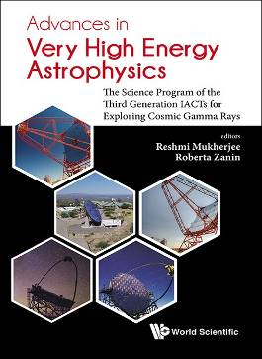 | Advances in Very High Energy Astrophysics  The Science Program of the Third Generation IACTs for Exploring Cosmic Gamma Rays  Edited by Reshmi Mukherjee (Columbia University, USA), Roberta Zanin (Cherenkov Telescope Array Observatory gGmbH, Italy)  492pp  978-981-327-571-3 US$178 £165  Release Date (Asia): Sep 2024  Release Date (Rest of the World): Oct 2024  http://www.worldscientific.com/worldscibooks/10.1142/11141

Very-high-energy astrophysics studies the most energetic photons in the sky, allowing the exploration of violent and extreme non-thermal phenomena in the Universe. Significant advances in knowledge have been made in this field using ground-based imaging atmospheric Cherenkov telescopes (IACTs) as detectors, to study these physical processes in the Universe. This book reviews the progress in the field since the advent of the second generation IACTs around 2004. Going through the scientific highlights obtained by the three current instruments of this kind, H.E.S.S., MAGIC and VERITAS, operating now for more than 15 years, this book presents a state-of-the-art knowledge in four areas of modern astrophysics and cosmology, namely the origin of the cosmic rays, the physics of compact objects and their resulting relativistic outflows, gamma-ray cosmology, and the search for dark matter. Along with a detailed review of the outstanding scientific outcomes, a summary of the key technological developments that yielded the recognized success of the technique is also provided.

This book is written for early-career academics in the fields of astrophysics, high energy physics and cosmology. At the same time, it can serve as a source of reference for the expert in the field.

Key Features:
- A timely review of advances in high-energy astrophysics following the observations by the third generation IACTs
- An ideal textbook for senior undergraduates or beginning graduate students. It could be the one-stop-shop for an academic in related fields
- Offers the young researchers a perspective on both the experimental developments as well as the scientific advances in the last ten years, informs them about the new challenges and open questions for future work

Contents: Very High Energy Gamma-Ray Astronomy; The Third Generation IACTS; The Status of the VHE Gamma-Ray Astronomy; Cosmic Ray Physics; Astrophysics; Cosmology; Fundamental Physics; Multi-Messenger Astronomy; Conclusions Before the Advent of C.T.A.;

Readership: Senior undergrads and academics in the fields of astrophysics, high energy physics and cosmology.

 | Recommended for Bookshops  The Living Record of Scientific History  Conversations with CN Yang  By Lizhen Ji (University of Michigan, USA), Liping Wang  400pp  978-981-12-8493-9 US$58 £55  Release Date (Asia): Sep 2024  Release Date (Rest of the World): Oct 2024  http://www.worldscientific.com/worldscibooks/10.1142/13641

Professor Chen-Ning Yang is best known for his achievements in Physics. He has also made significant contributions to the development of mathematics, as mathematics is extensively used in his research. In his long and fruitful academic career, he has witnessed many important events in the fields of Physics and Mathematics, and has collaborated or interacted with many great scientists in history. This book records eight interviews with Professor Chen-Ning Yang, which were conducted by the authors from 2016 to 2019.
Through Professor Yang's unique perspective, major scientific events in the 20th century were revisited vividly, elaborating the development and mutual influences of mathematics and physics, as well as unveiling the academic work, the daily lives, and the personalities of scientists, as well as their collaboration and competition, some stories unknown to the public before are also revealed in this book.
Key Feature:
- From the unique perspective of C N YANG, this book reveals the development of world mathematics and physics and the mutual influence between mathematics and physics in the past 100 years
Contents: Preface; The First Interview (August 4, 2016); The Second Interview (March 1, 2017); The Third Interview (March 6, 2017); The Fourth Interview (July 4, 2017); The Fifth Interview (July 30, 2018); The Sixth Interview (August 8, 2018); The Seventh Interview (March 6, 2019); The Eighth Interview (June 20, 2019); Appendix;
Readership: Undergraduate/graduate/researchers in physics/mathematics/science. General audience interested in history of science.

 | Physics to Philosophy and Back  A Search for the Limits of Physics  By Fedde Benedictus (Utrecht University, the Netherlands)  200pp  978-981-12-9269-9 US$88 £80  978-981-12-9283-5(pbk) US$48 £45  Release Date (Asia): Sep 2024  Release Date (Rest of the World): Oct 2024  http://www.worldscientific.com/worldscibooks/10.1142/13825

What do we really know about the world? Physics utilizes complex equations to avoid having to answer philosophical questions like this. Consider, for example, the fact that the motion of particles is described in terms of straight lines, while any line that we can actually draw is never perfectly straight. Working physicists adopt many of such presuppositions, rarely stopping to question the correspondence between physical equations and reality. This has resulted in the common misconception that there is a clear divide between Newton's 17th century physics and that of Einstein's on account of different mathematical descriptions. However, if equations do not always represent reality, what can they tell us about reality?

This book focuses on some of the philosophical problems underlying all theories in physics, such as the nature of time (is time just 'that which is measured by a clock' or is it more than that?). It may seem as if these problems were more or less solved in the three-and-a-half centuries that have passed since Newton's time. But the philosophical 'open ends' were the same for Einstein and remain the same to this day. Philosophy and physics are two sides of the same coin.

Filled with personal anecdotes and amusing examples, this book provides the perfect introduction to the topic for readers with a non-scientific background. It also enables the reader to come to their own informed conclusion about the relation between physics and the reality in which we live.

Key Features:
- Addresses both physicists and philosophers to enable cross-discipline discourse on the fundamental philosophical basis of physics research
- Discusses important foundations of what scientists knows about reality in order to reinforce popular trust in science
- Provides interesting fresh perspectives on Einstein's and Newton's theories according to what we know today
- Endorsed by Nobel Laureate Gerard 't Hooft

Contents: Preface by Gerard 't Hooft; Part One: Introduction; Newton; Newton Intuitive?; Masks of Reality; Part Two: Introduction; Special Relativity (1905); General Relativity (1915); Space, Time, and Gravity since Einstein; Description and Explanation; Further Reading Index;

Readership: Readers of popular science, popular physics, and philosophy. Physicists and amateur philosophers will also benefit.

SOCIAL SCIENCES （社會科學）
 | Recommended for Bookshops  Feminism Undaunted  50 Years as a Muslim Feminist  By Wazir Jahan Karim (Universiti Sains Malaysia, Malaysia)  250pp  978-981-12-6200-5 US$58 £55  Release Date (Asia): Sep 2024  Release Date (Rest of the World): Oct 2024  http://www.worldscientific.com/worldscibooks/10.1142/13016

Wazir Jahan engages the reader in absorbing stories from her childhood to retirement against a backdrop of events in Malaysia — cultural, academic and political — which elucidates the complexities of being a Muslim feminist, in a divisive Asian society. Her narrative demonstrates that each woman can successfully negotiate the boundaries between patriarchy, family and modernity if they believe that being a woman is synonymous with being a feminist - that institutions which obstruct women's path to freedom can be challenged through recognising the power of individualism. Jahan believes that once a woman understands what can work well for her, within the limitations of her own achievements and resources, she could be able to rise above these intimidations of life and actively engage in pursuing her dreams. For Jahan, femininity and feminism are complementary forms of activism which enabled her to gain acceptance and legitimacy for her work with disadvantaged and minority women. Her frank and refreshing confessions of success and failures in her work on women and gender demonstrates confidence, individuality and charisma — a catharsis in the journey to discovering the power of womanhood.

Key Feature:
- A unique approach to feminism as the power of womanhood; a guide to mentoring students on the importance of individualism in academic achievement; in-depth observations of Malaysian Islam from a feminist perspective; the emergence of political forms of oppression towards minority women and groups and why they are targeted by politicians; Jahan's own colourful career as a feminist in an oppressive academic institution which saw feminism as a challenge to the status-quo of maleness in a tertiary education

Contents: Malaya, 1955; Early Beginnings, Lahore, 1873; The Women's Institute; The Convent; Secret Readings; Eusoff College; The Social Sciences; The LSE; A Femme Fatal; Do Not Forget Us; Feminist Fields; KANITA; Passions of Faith and Love; Cambridge Conversations; Epilogue;

Readership: Undergraduates, graduates and researchers interested in the intersectionality between feminism, race, religion and society.

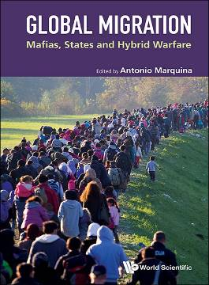 | Global Migration  Mafias, States and Hybrid Warfare  Edited by Antonio Marquina (Complutense University of Madrid, Spain)  200pp  978-1-80061-594-6 US$88 £80  Release Date (Asia): Sep 2024  Release Date (Rest of the World): Oct 2024  http://www.worldscientific.com/worldscibooks/10.1142/q0470

This book covers the issue of global migration flows, with a particular focus on irregular migration. It presents and evaluates the principal drivers of migration as well as recent policies implemented to handle these flows in East and South Asia, the European Union and the United States.

Crucially, the chapters explore how different actors interact in using or promoting migratory flows from a humanitarian, political, criminal and security point of view, thereby highlighting the central role played by migrant-smuggling mafias. The book draws attention to the fundamental role of such mafias, their growing transformation and transnationalism, and the inadequate response and adaptation of state policies and police forces. It also highlights the increasing use of migration by various states in their policies of influence, if not aggression, towards third countries, in the absence of a clear deterrent response. Looking to the future, the book highlights the growing importance of the complex issue of environmentally-induced migration.

Contents: Preface by Antonio Marquina; What is the European Union Doing to Combat Illegal Migration? (Gloria Inés Ospina); Migration Flows from North Africa to Spain: Changes in Migration Flows, Role of Mafias and Blackmail from Third States (Antonio Marquina); Irregular Migration Flows to Italy: Critical Role of Mafias and Diasporas (Gianluca Pastori); Economic Aspects of Migration to Italy (Gianluca Pastori); Irregular Migration Flows to Greece: Humanitarian and Security Aspects (Agapi Kandylaki and Kostas Ifantis); International Migration Flows in South Asia: Social and Economic Dimensions in the 21st Century (Aleksandra Jaskólska); Migration Flows from ASEAN: State Regulations, Role of Mafias (Surwandono and Ali Maksum); Changes and Disagreements Between Democrats and Republicans on Irregular Migration and Border Protection Policies: Humanitarian and Criminal Consequences (Gloria Inés Ospina); Linking Climate Change and Migration: An Overview of Factors Behind Human Displacement (Xira Ruiz and Angeles Portela);

Readership: This book is suitable for advanced undergraduate and graduate students in International Relations, Migration Studies, Security Studies, Foreign Policies, Regional Studies and Globalization. It is also suitable for researchers in these disciplines as well as professionals in diplomacy, demography, security and intelligence.

